**EX NO: 1 INSTALLATION OF VIRTUAL BOX WITH LINUX OPERATING**

**SYSTEM ON THE TOP OF THE WINDOWS OS**

**DATE: 28.08.2021**

**AIM:**

To install virtual box with different flavours of LINUX or windows OS on top of windows 10 or 7 or 8.

**PROCEDURE:**

**Step 1:** Search Virtual box and open the [www.virtualbox.org](http://www.virtualbox.org) then choose the windows host.

**Step 2:** Then the virtual box is get downloaded in the system.

**Step 3:**  Then provide the setup in the following setup to install virtual box in windows.

1. Click next button.
2. Then click next button.
3. Then click next button.
4. Then undergo the procedures in the below
5. A pop with box of that “Would you like to install this devise software?”

Select install option in it.

1. The virtual box get installed successfully and ready to use.

**Step 4:** Launching Ubuntu OS in virtual box.

1. Download Ubuntu OS for desktop version of 20.04 LTS.
2. Then in virtual box click new to create a virtual machine and type name as Ubuntu 2018 and click next button.
3. Then allocate a memory size of 1024MB and click next next button and choose create a virtual hard disk now and then click create.
4. Then choose dynamically allocated and click next button.
5. Then select the size of the virtual hard disk for 10.00GB and click create button.
6. Choose settings and click storage in controller IDE add the Ubuntu OS in it and the click ok button.
7. Then the Ubuntu OS with virtual box is ready to use.
8. Then click start button then the ubuntu OS get started running.

**Step 5:** Setting up the Ubuntu OS to use.

1. Choose “Install Ubuntu “ in box.
2. Choose the language in it.
3. In updates and other option select the following one in the below and click continue.
4. Then choose the install type as “Erase disk and install Ubuntu” and choose install now button.
5. Then click continue button.
6. Then set up your user name and password for login in Ubuntu.
7. Then the ubuntu OS is ready to use.

**OUTPUT:**

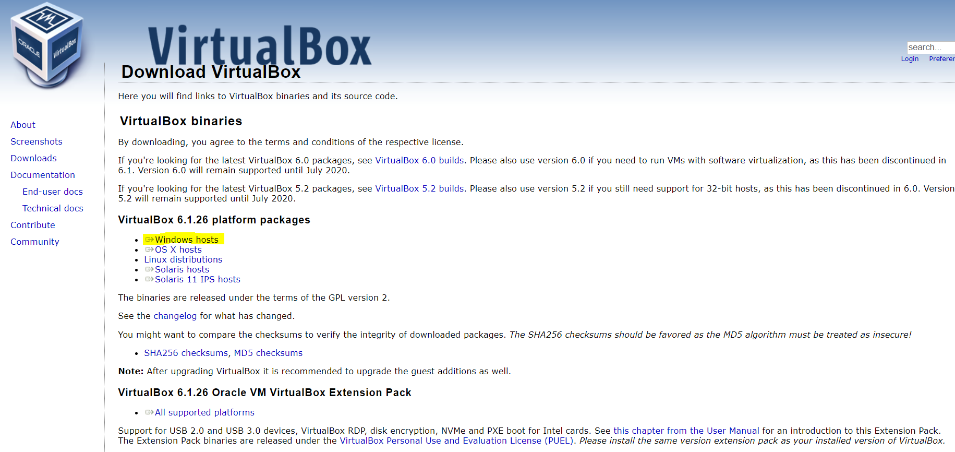



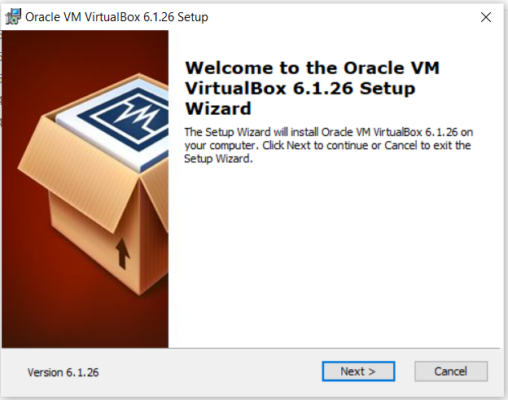

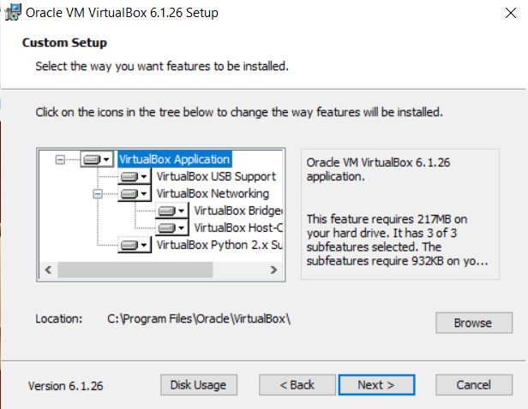

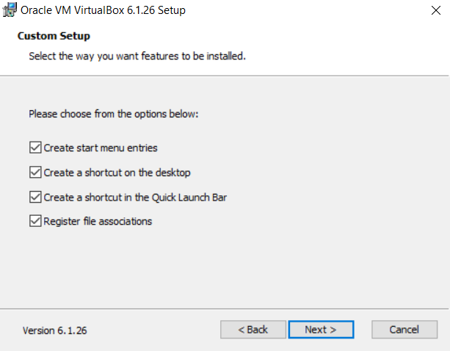

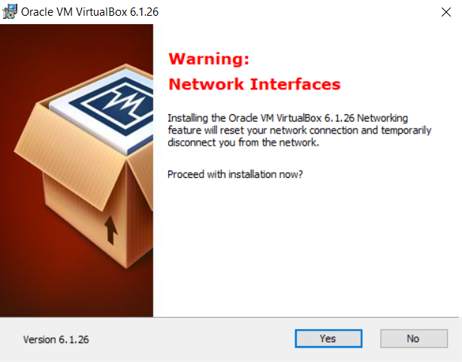

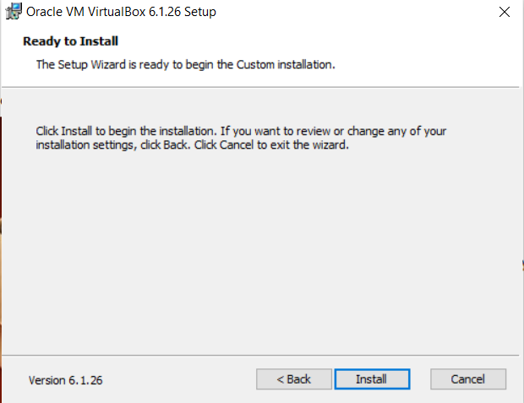

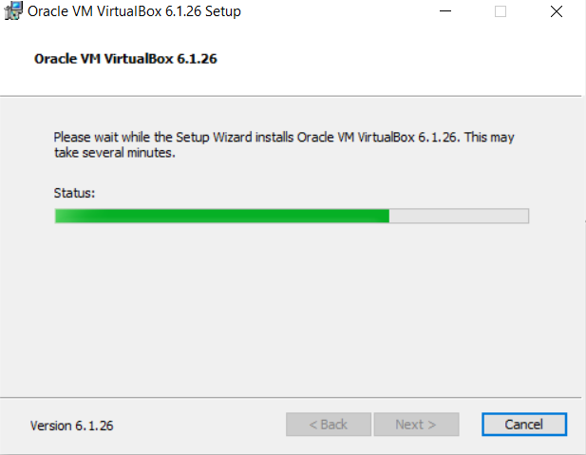

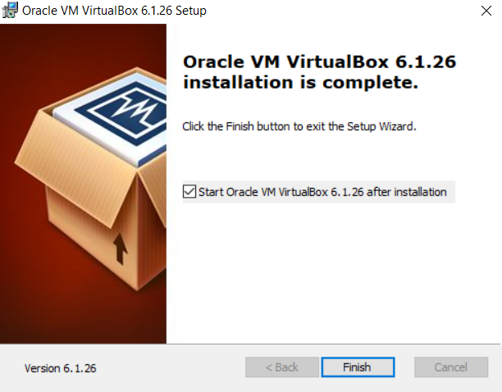

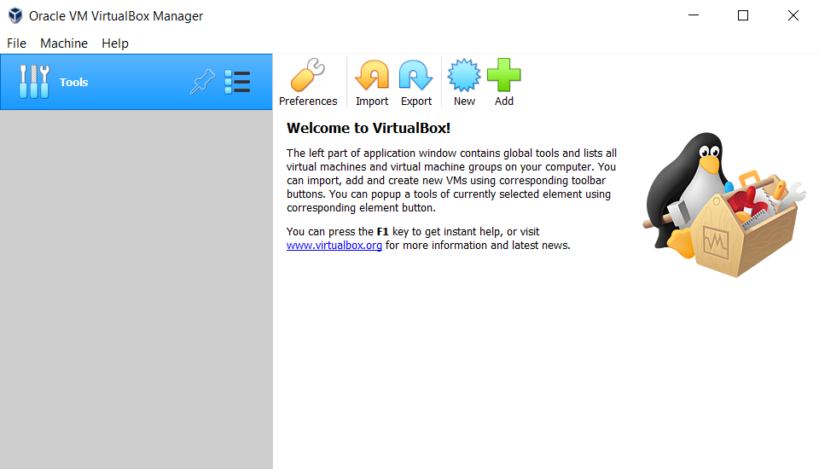

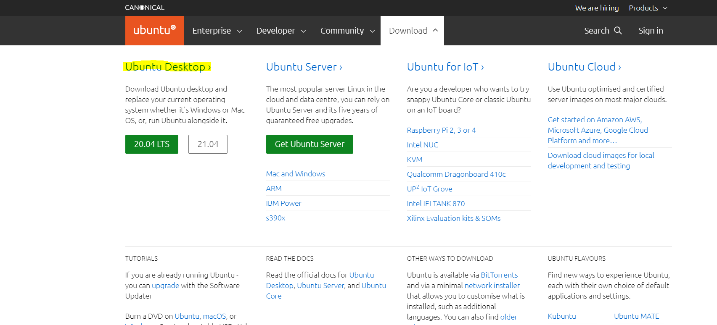

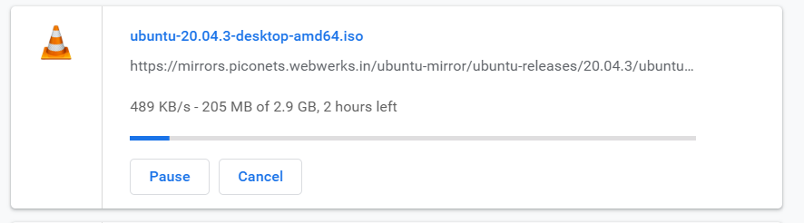

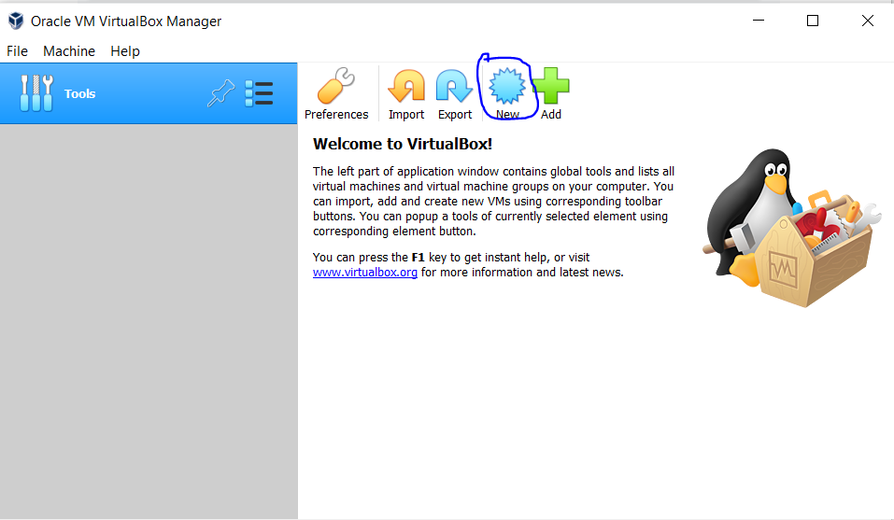

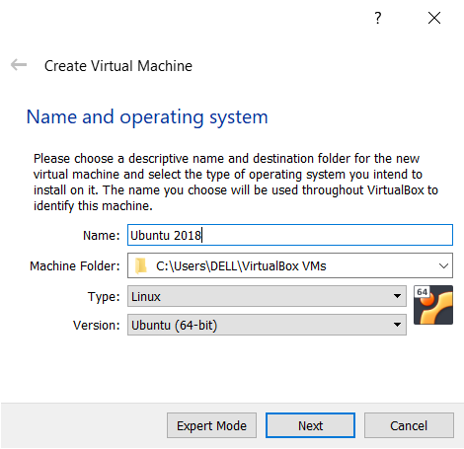

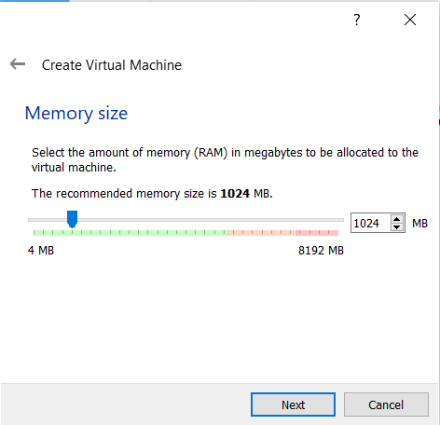

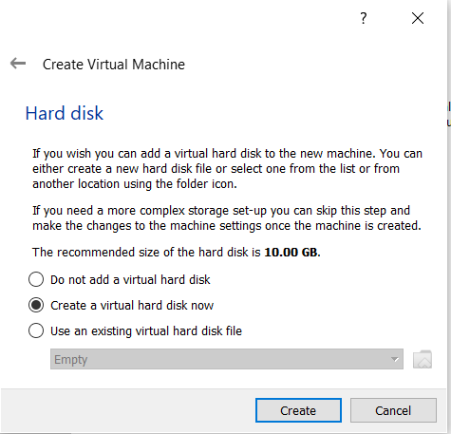

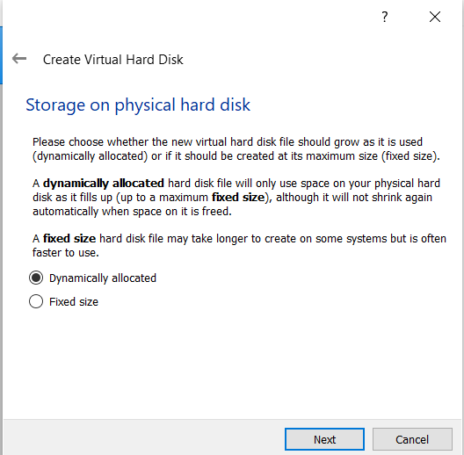

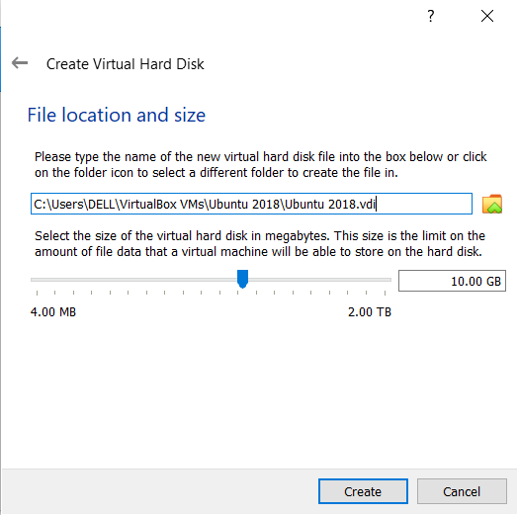

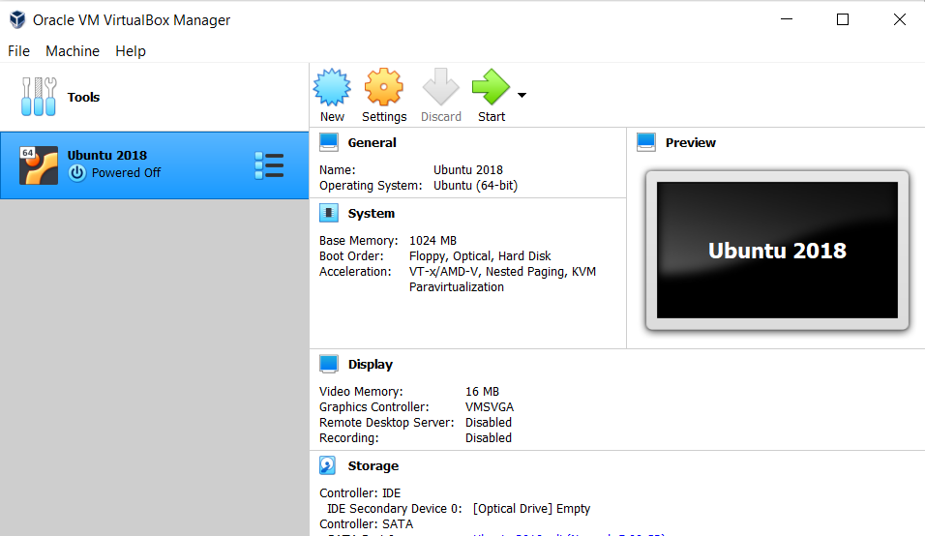

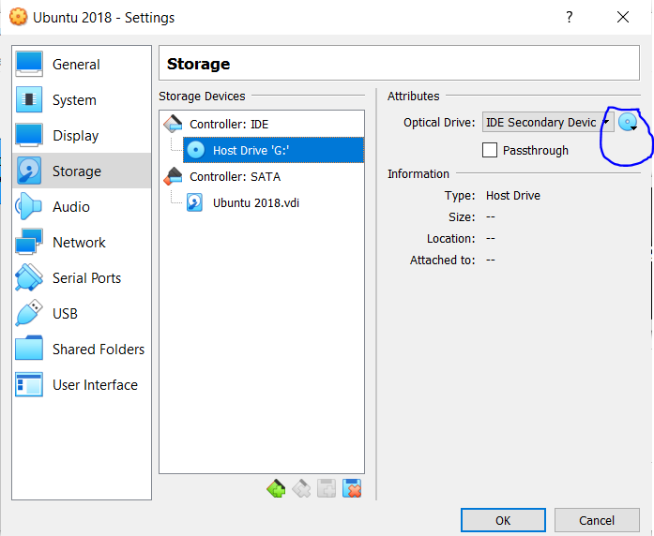

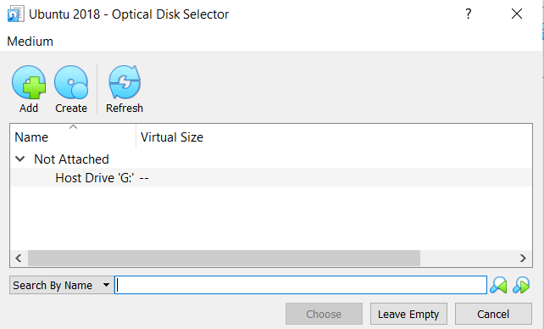

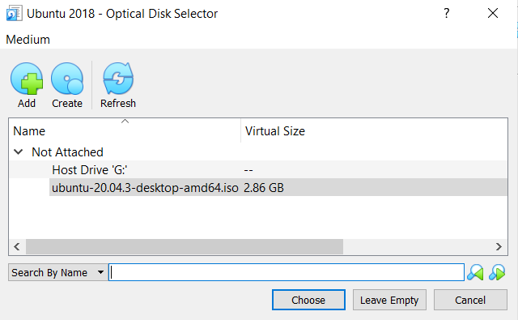

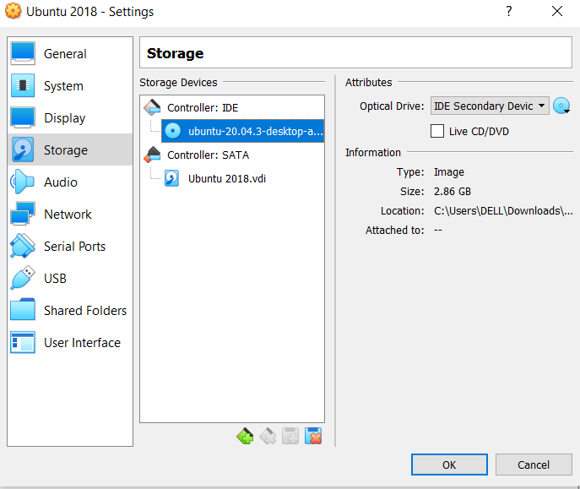

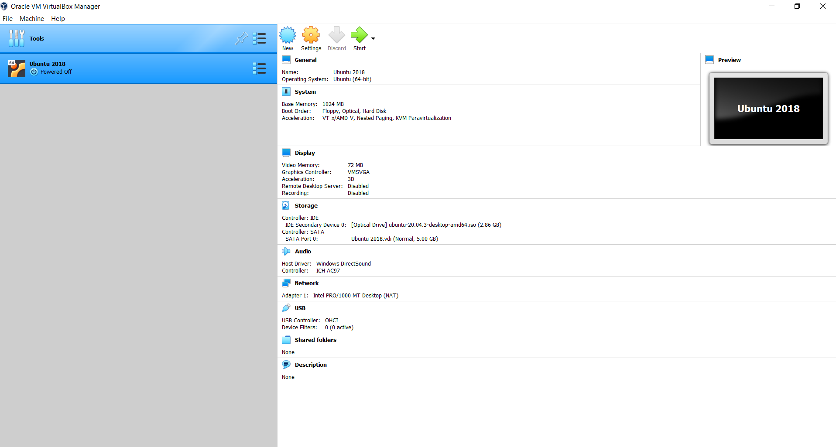

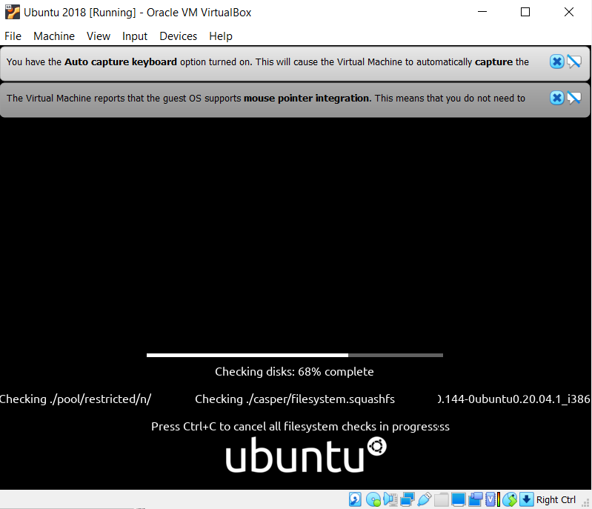

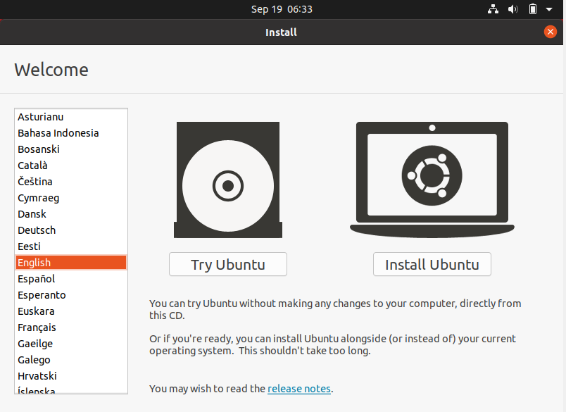

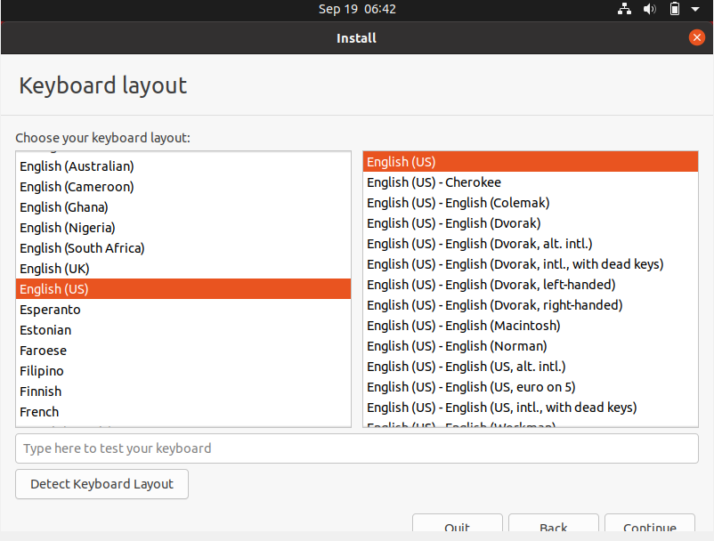

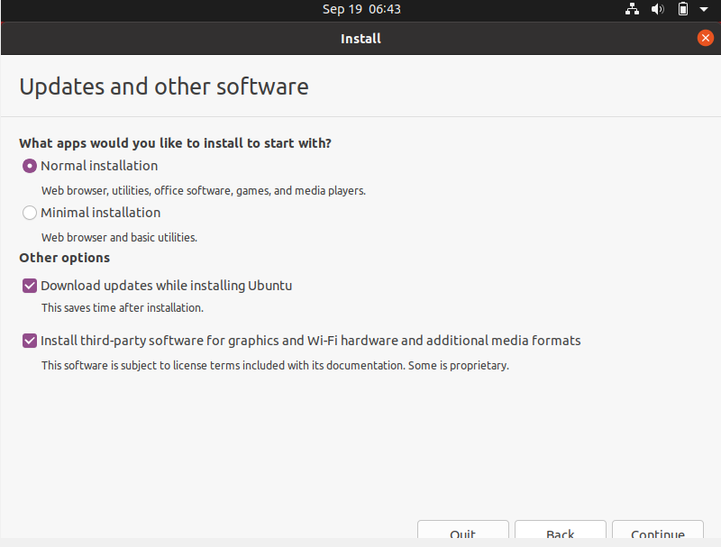

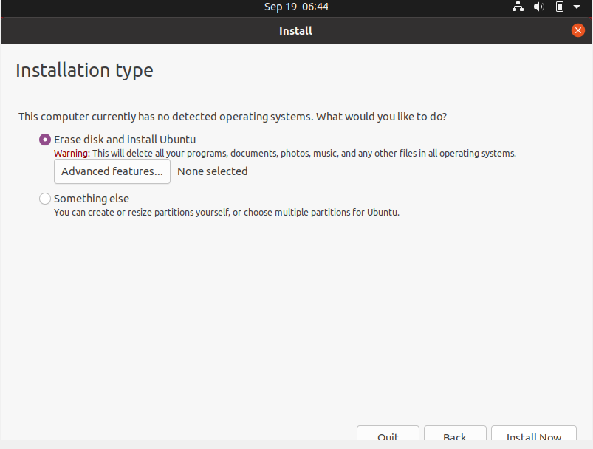

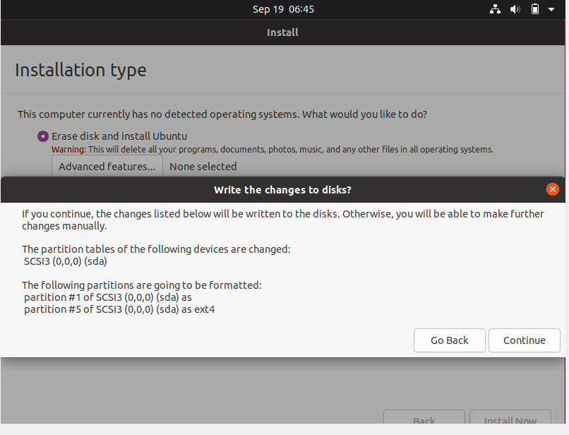

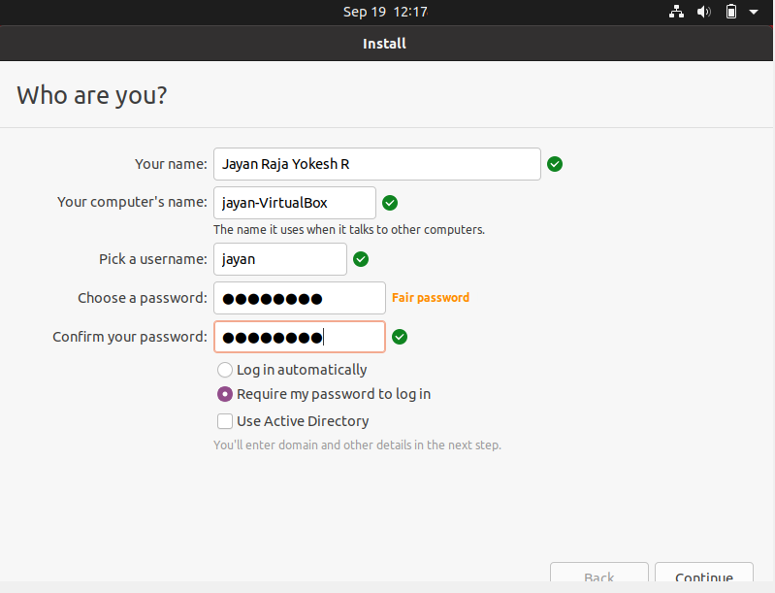

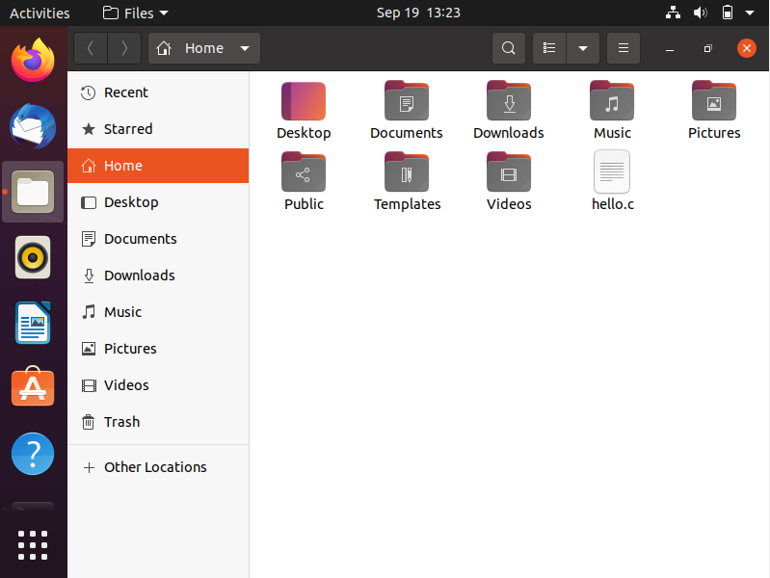

|  |  |
| --- | --- |
| **Observation** |  |
| **Record** |  |
| **Total** |  |
| **Course Incharge** |  |

**RESULT:**

The virtual box is installed and Linux OS is executed successfully.

**EX NO: 2 INSTALLATION OF C COMPILER AND EXECUTION OF**

**SIMPLE PROGRAM ON VIRTUAL BOX**

**DATE: 04.09.2021**

**AIM:**

To install a computer in the virtual machine created using virtual box and execute simple program.

**PROCEDURE:**

**Step 1:**  Open the virtual box and start the virtual machine and open the terminal.

**Step 2:** Now to install the C compiler type “sudo apt install build -essential” and click enter and then type yes to install.

**Step 3:**  Now using the “touch” command create a file and type a simple C program and save the file.

**Step 4:** Now type gcc filename.c to compile the file and then type ./test then run the program.

**Step 5:** The output is displayed in the terminal as well.

**Step 6:**  end.

**OUTPUT:**

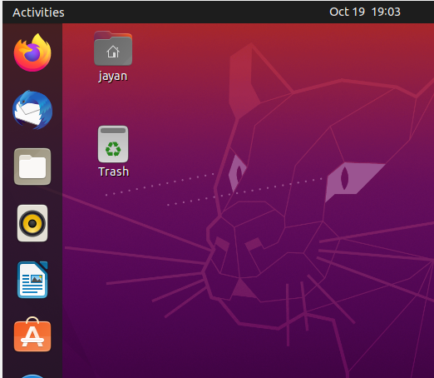

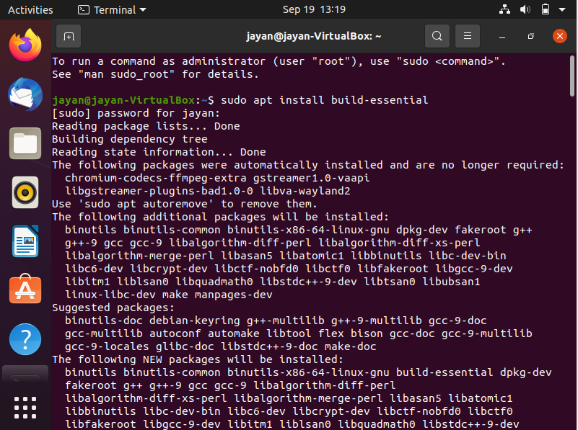

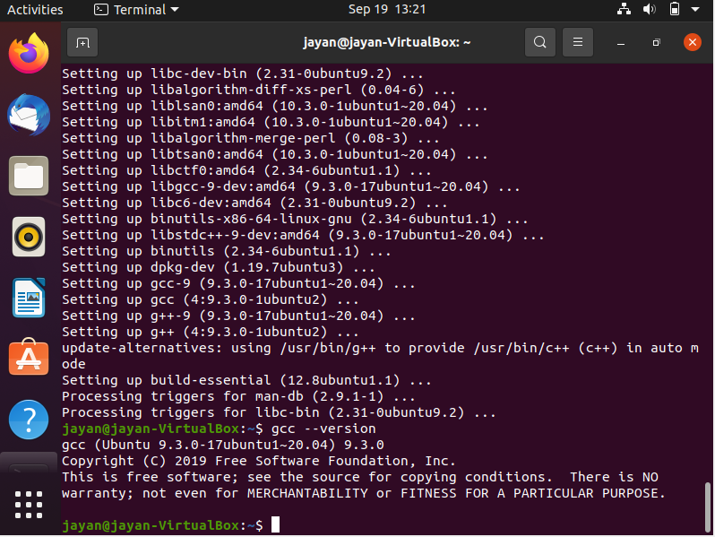

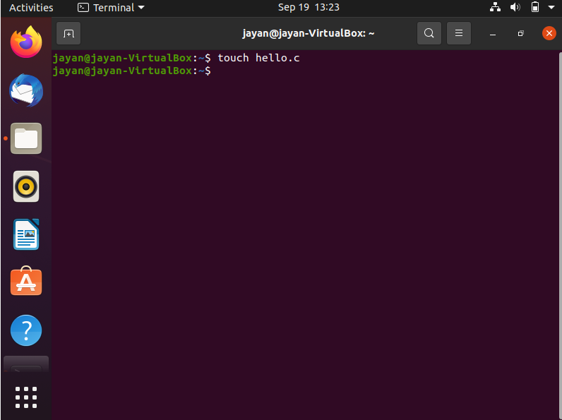

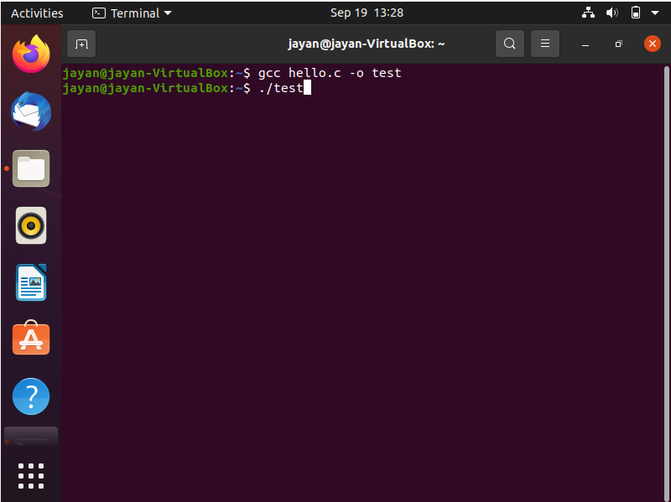

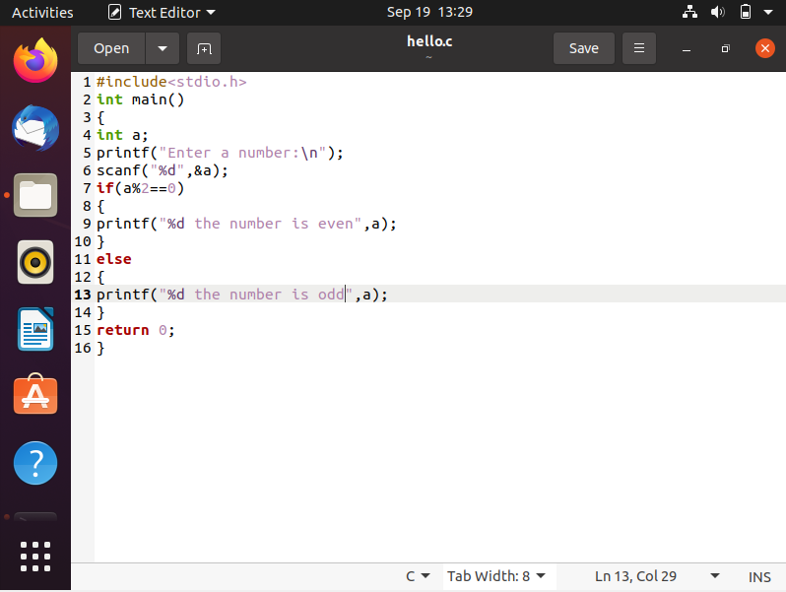

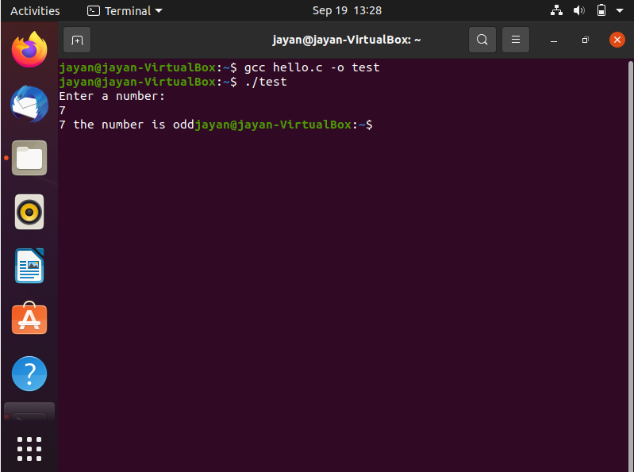

|  |  |
| --- | --- |
| **Observation** |  |
| **Record** |  |
| **Total** |  |
| **Course Incharge** |  |

**RESULT :**

The C compiler has been installed and program executed successfully.

**EX.NO: 3 INSTALLATION OF VMWARE WITH LINUX OPERATING**

**SYSTEM ON THE TOP OF THE WINDOWS OS**

**DATE: 06.09.2021**

**AIM:**

To install vmware workstation with different flavour of LINUX or WINDOWS OS on the top of windows 10 or 7 or 8.

**PROCEDURE:**

**Step 1:** Downloading vmware workstation in windows

1. Choose windows host of the vmware workstation and download. Vmware workstation get installed.

**Step 2;** Install vmware workstation

1. Open the folder where vmware workstation installer was downloaded.
2. Right click on installer and click run as administrator.
3. Select the setup location and follow the instruction.

**Step 3:** Launch the LINUX in vmware workstation

1. Open vmware workstation
2. Create new virtual machine
3. Follow the instruction and select the OS as linear 64-bit.
4. Select the file location
5. Select the split virtual disk into multiple files.
6. Click finish button
7. Open settings and select CD/DVD(IDE)
8. Select the file and click ok
9. Then open the Ubuntu OS via virtual machine.

**OUTPUT:**

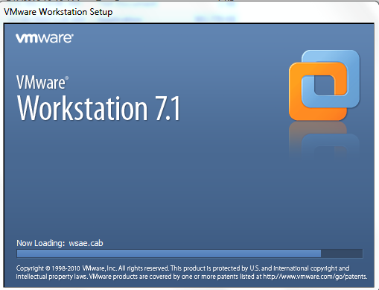

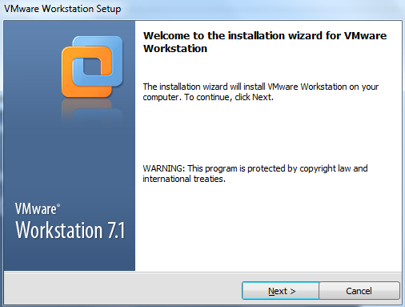

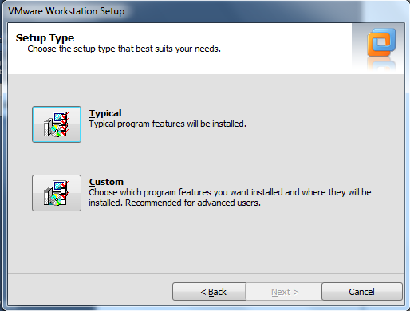

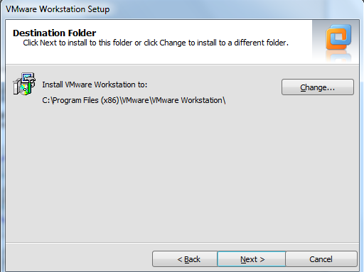

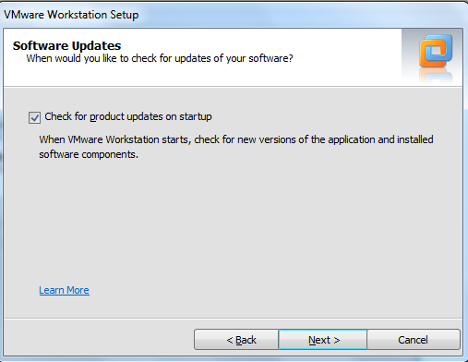

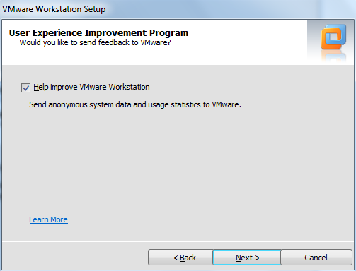

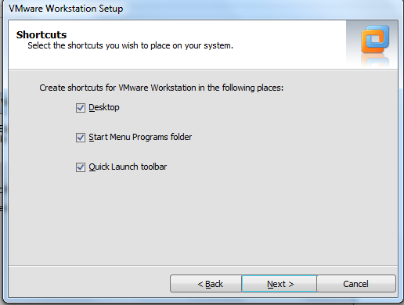

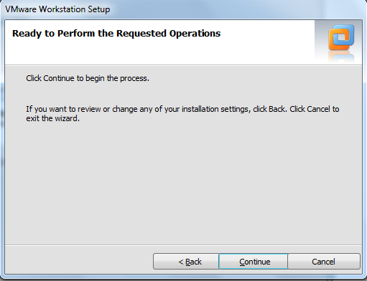





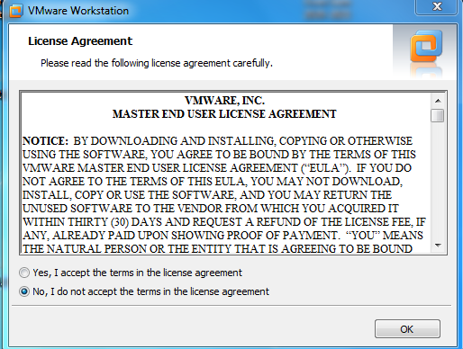

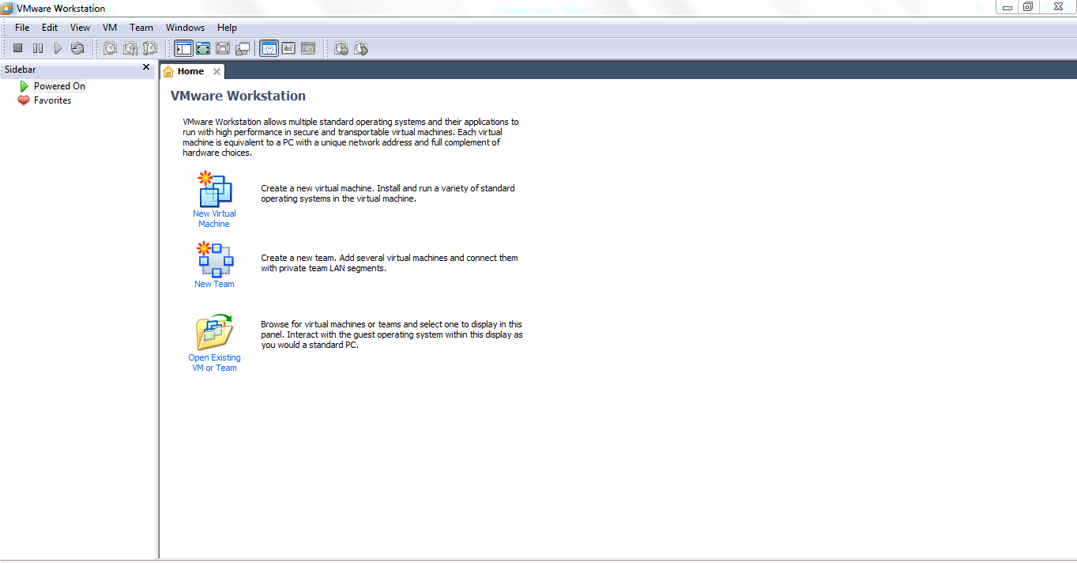

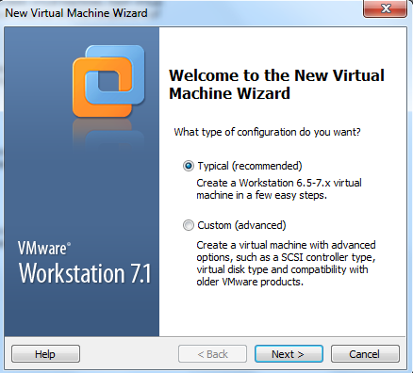

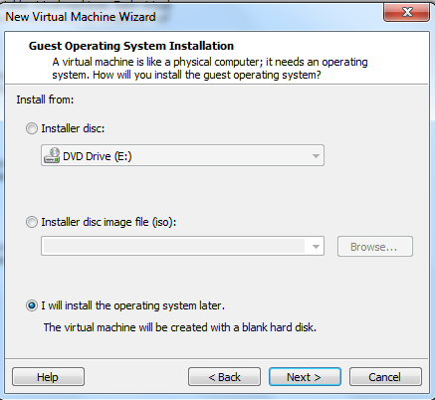

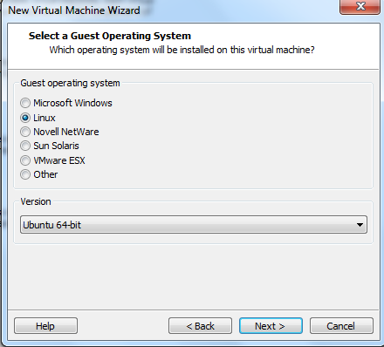

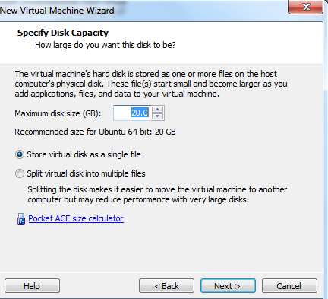

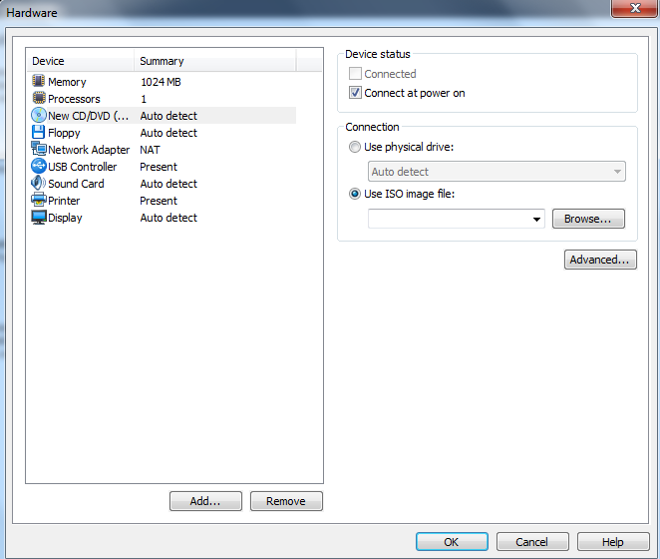

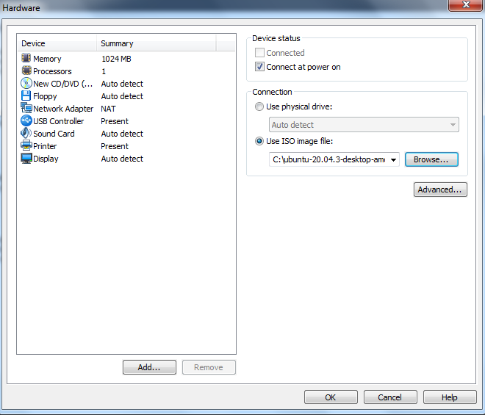

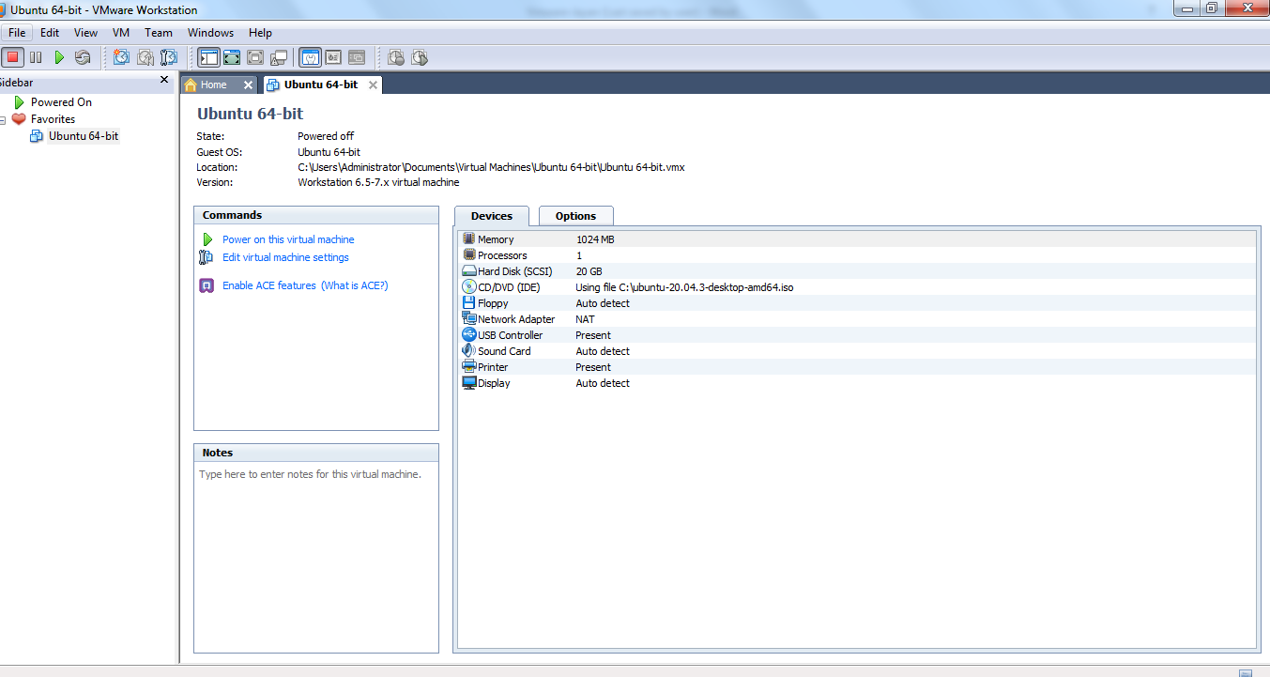

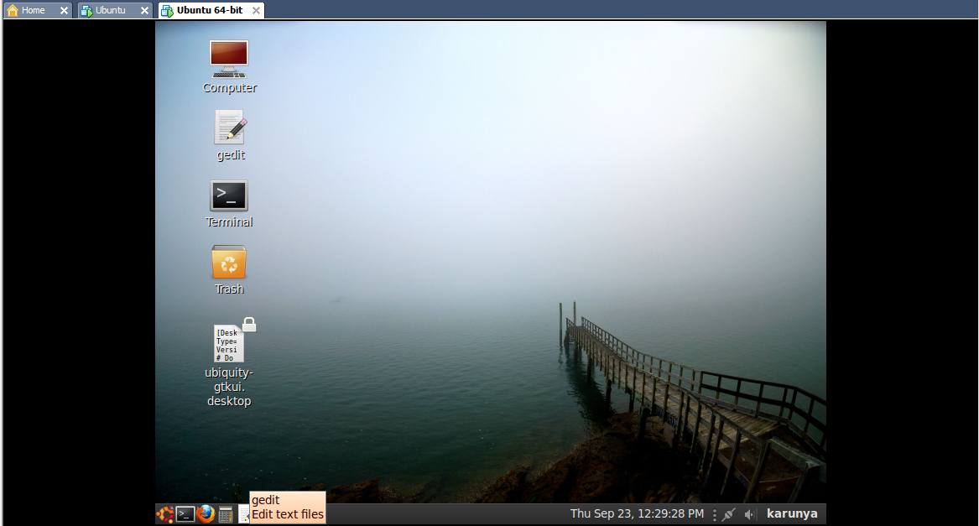

|  |  |
| --- | --- |
| **Observation** |  |
| **Record** |  |
| **Total** |  |
| **Course Incharge** |  |

**RESULT:**

Thus, the installation of VMware workstation with LINUX OS on top of windows OS.

**EX.NO: 4 INSTALLATION OF C COMPILER AND EXECUTION OF**

**SIMPLE PROGRAM ON VMWARE WORKSTATION**

**DATE: 15.09.2021**

**AIM:**

To install C compiler and to execute a simple program on vmware workstation.

**PROCEDURE:**

1. Open the vmware workstation and open the terminal in that
2. Create a file using touch command

* $ touch sample.c

1. Type the program in that file
2. Compile the program file using gcc command
3. Command is

* $ gcc sample.c

1. Get input from the user.
2. Use ./a.out command to print the output.

**OUTPUT:**

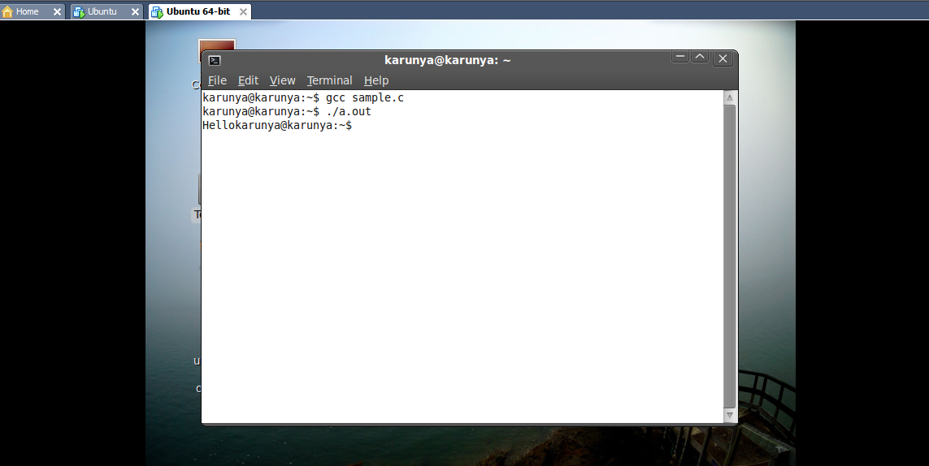

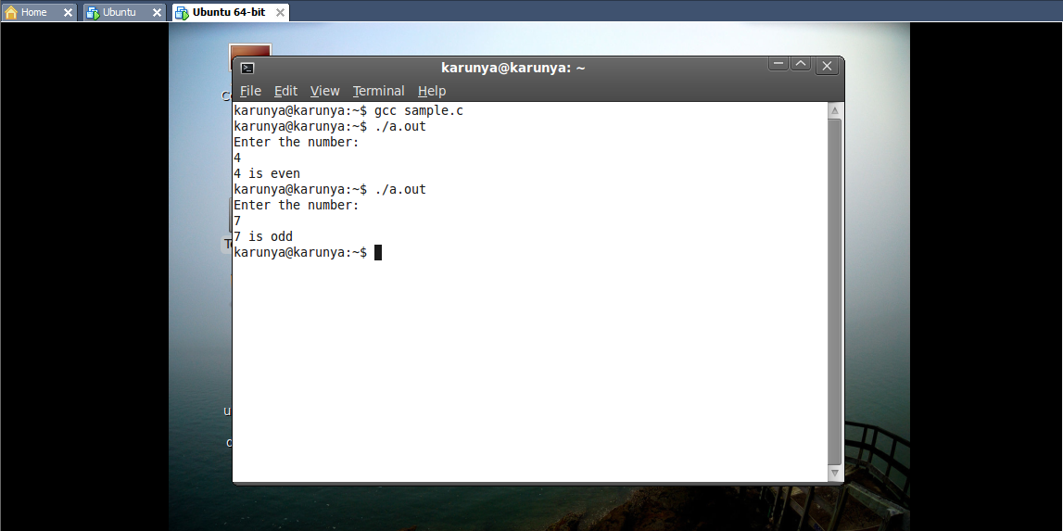

|  |  |
| --- | --- |
| **Observation** |  |
| **Record** |  |
| **Total** |  |
| **Course Incharge** |  |

**RESULT:**

Thus, the installation of C compiler and execution of sample program on vmware workstation are get done and get verified.

**EX.NO: 5 INSTALLATION OF GOOGLE APP ENGINE & CREATION OF**

**SIMPLE WEB APPLICATION USING PYTHON**

**DATE: 23.09.2021**

# AIM:

To install Google App Engine & Creating of Simple Web Application using Python

# DESCRIPTION:

Google App Engine is a fully managed serverless platform for developing and hosting web applications at a scale. Users can choose from several popular languages, libraries, and frameworks to develop their applications and then App Engine takes care of provisioning servers and scaling app instances based on demand. It is a PaaS for building scalable applications.

# PROCEDURE:

Step 1: Download the latest version of python from the official website [www.python.org](http://www.python.org/)

Step 2: Install the python in the system and check on the cmd by typing python and press enter to check the version correctly

Step 3: Now open the cloud.google.com, the google app engine

Step 4: Click the python version ➔quick start➔download the cloud sdk installer.

Step 5: Run the installer and select the necessary options and click finish once it has been installed.

Step 6: Once it is installed, the Google Cloud SDK Shell will open type y to proceed further

Step 7: Choose a google account to login in and once logged in the installation is completed and ready for use.

Step 8: Create a new Folder and file test.py and create a web application and also create the .yaml file.

Step 9: In the Google Cloud SDK Shell type google-cloud-sdk\bin\dev_appserver.py followed by the location of the folder in your system

Step 10: It will run and display a localhost url copy and paste it in the browser and click enter

Step 11: The google instance page will open click default.

Step 12: The output will be displayed on the localhost.

# OUTPUT:

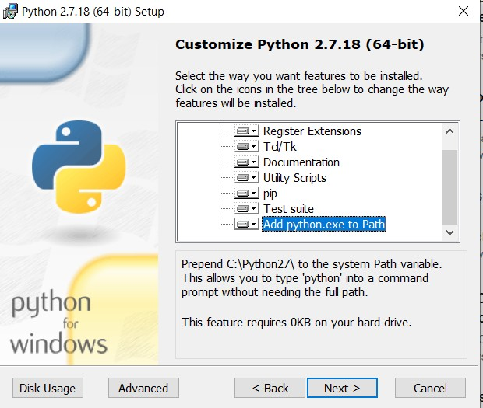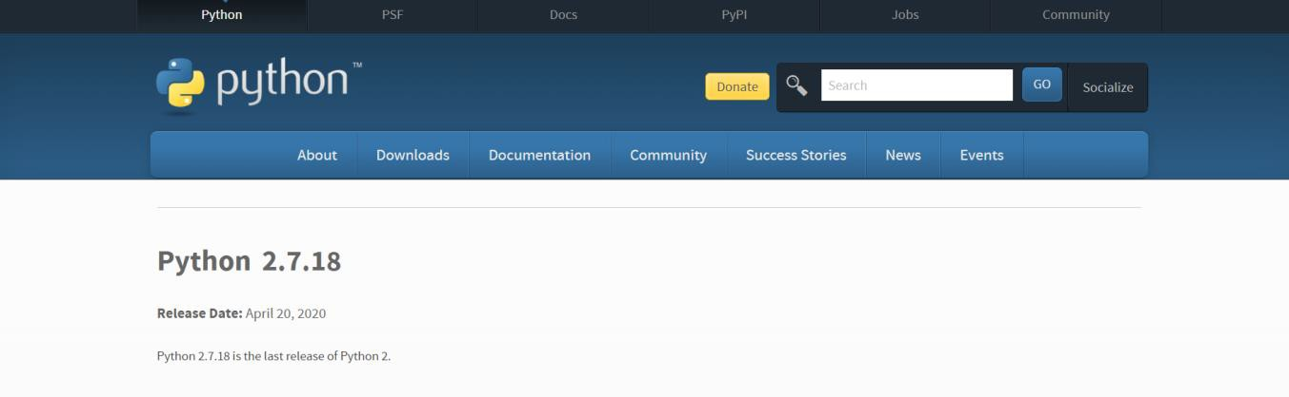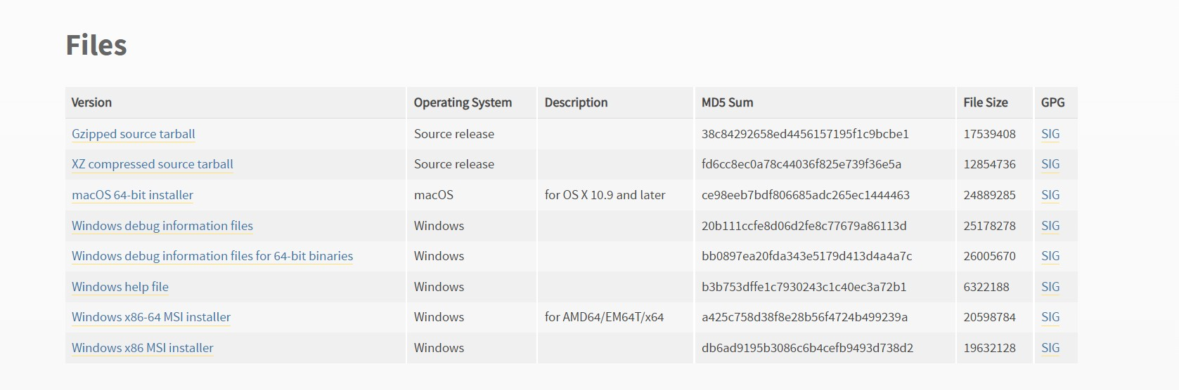

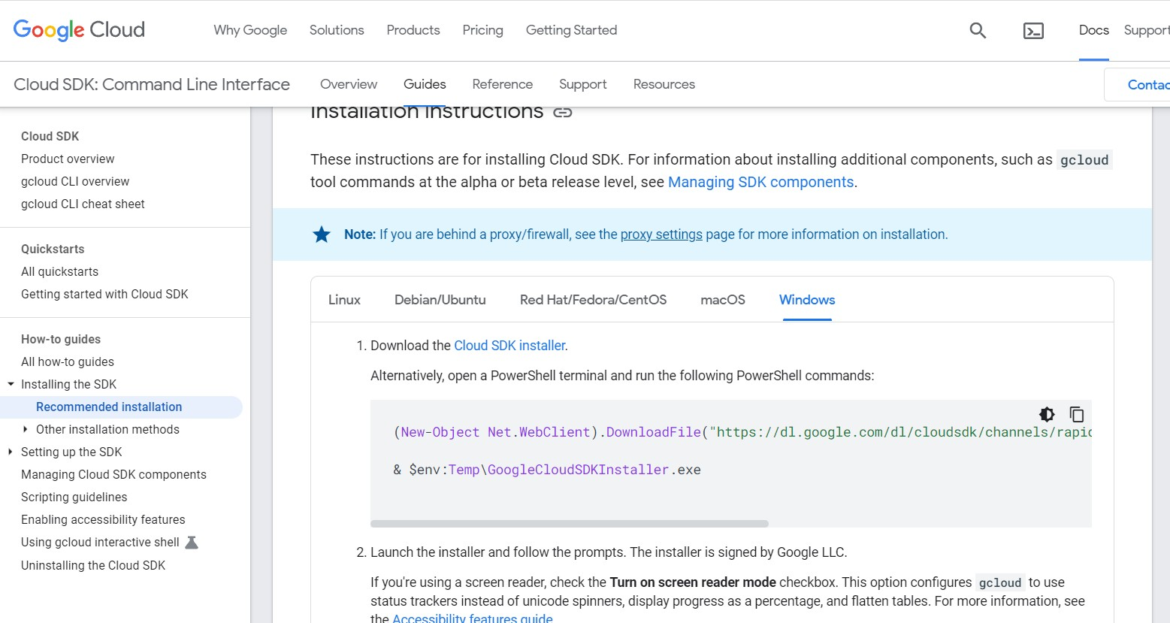

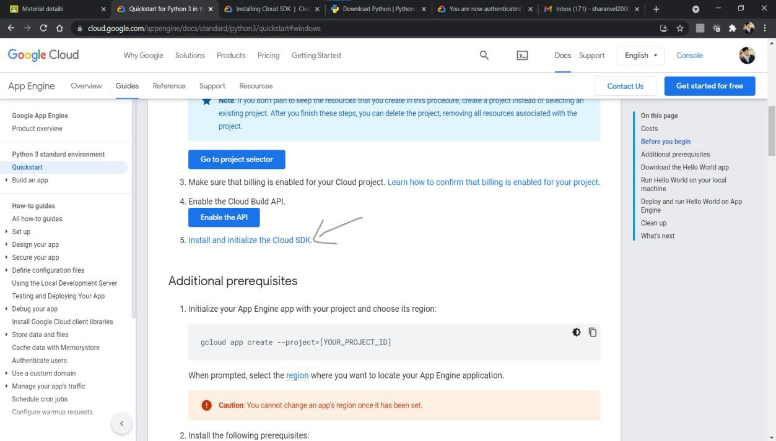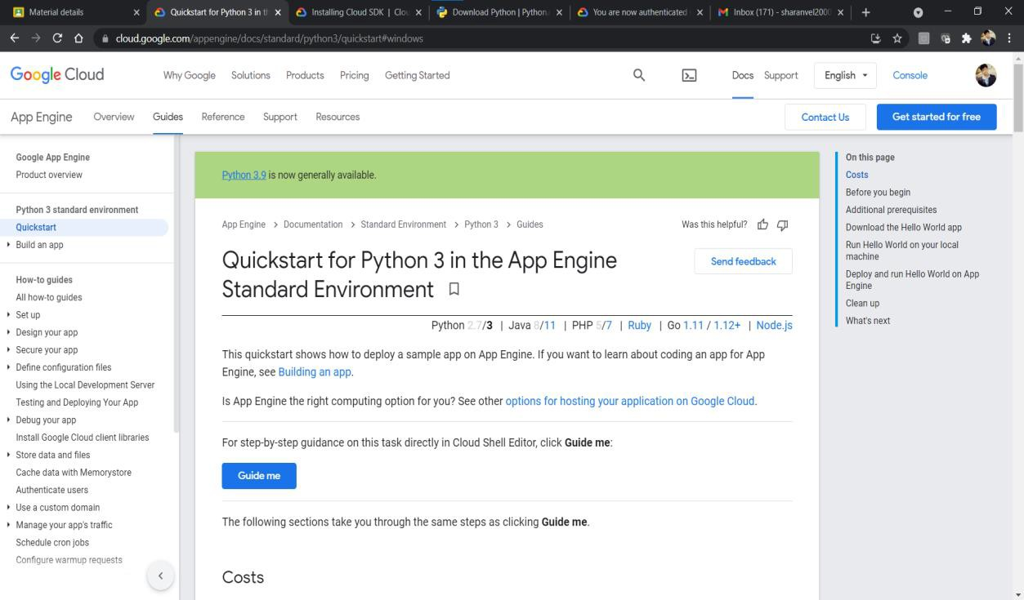

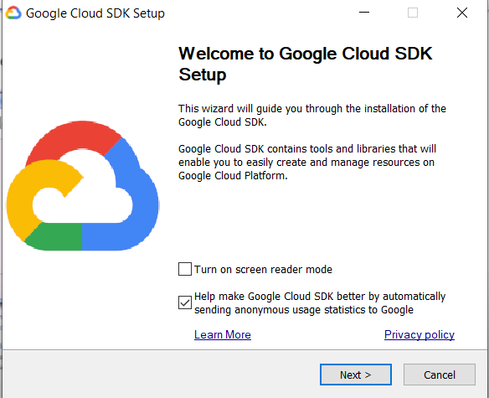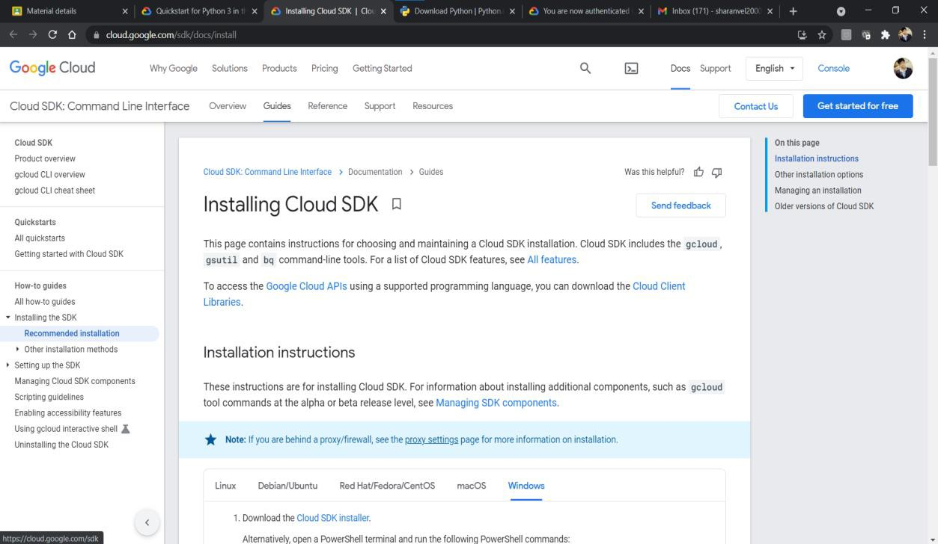

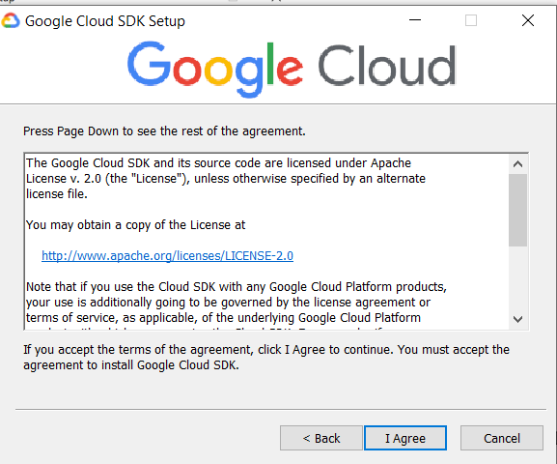

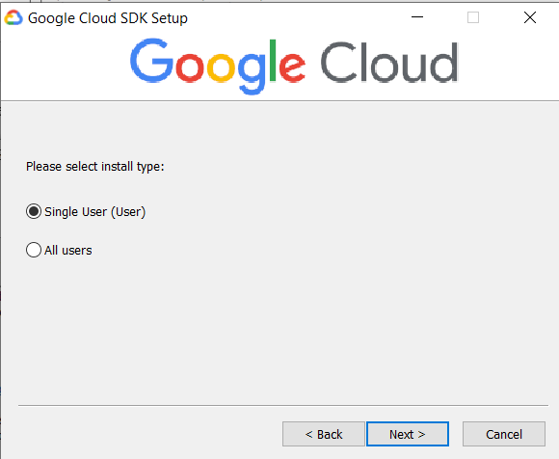

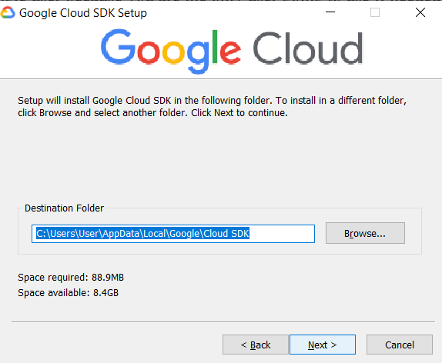

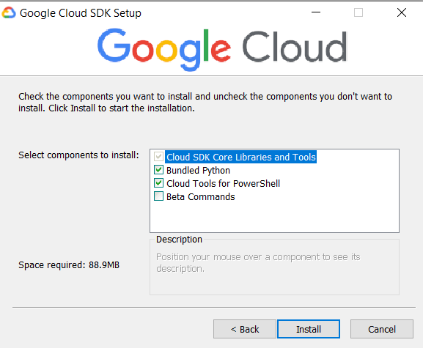

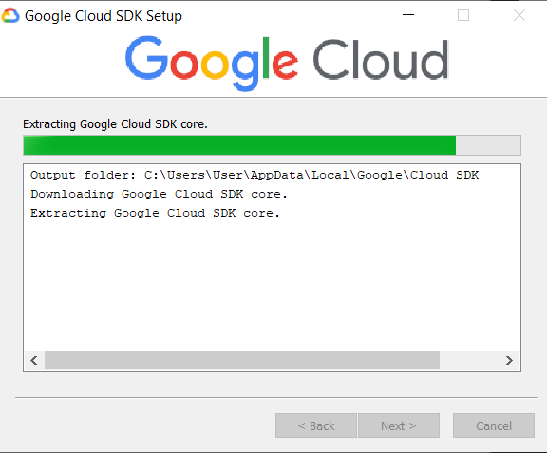

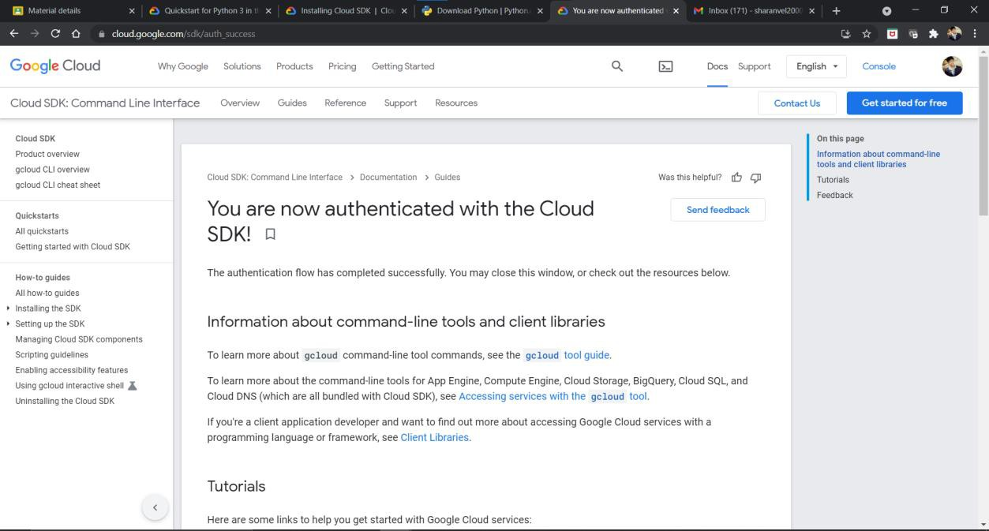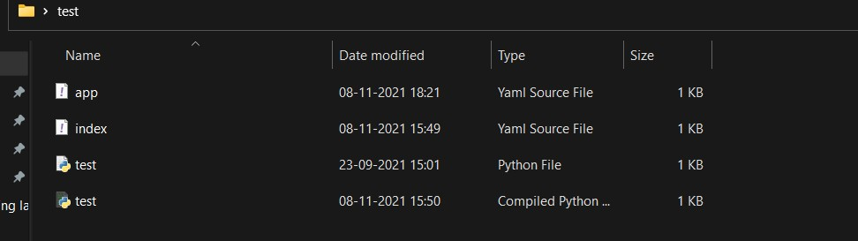

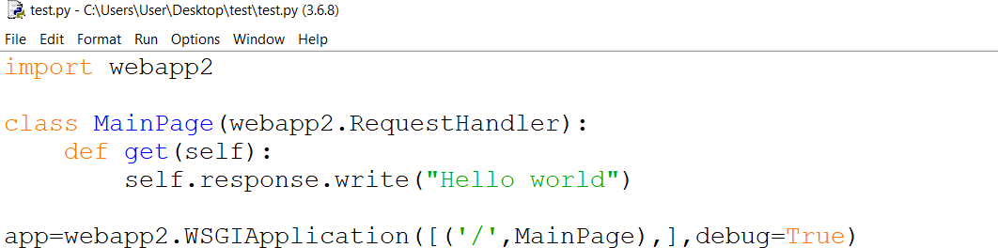

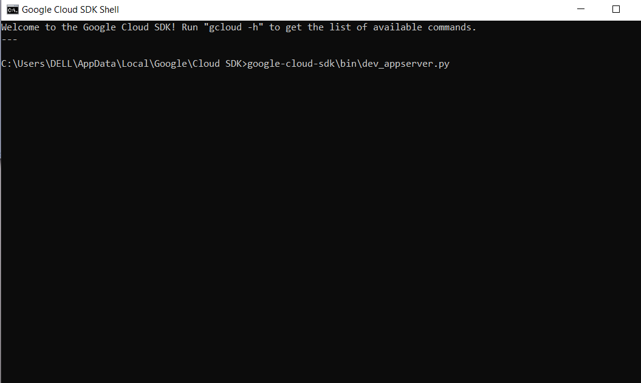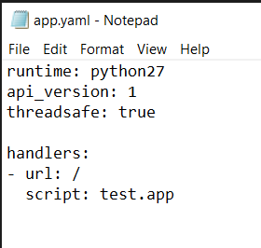

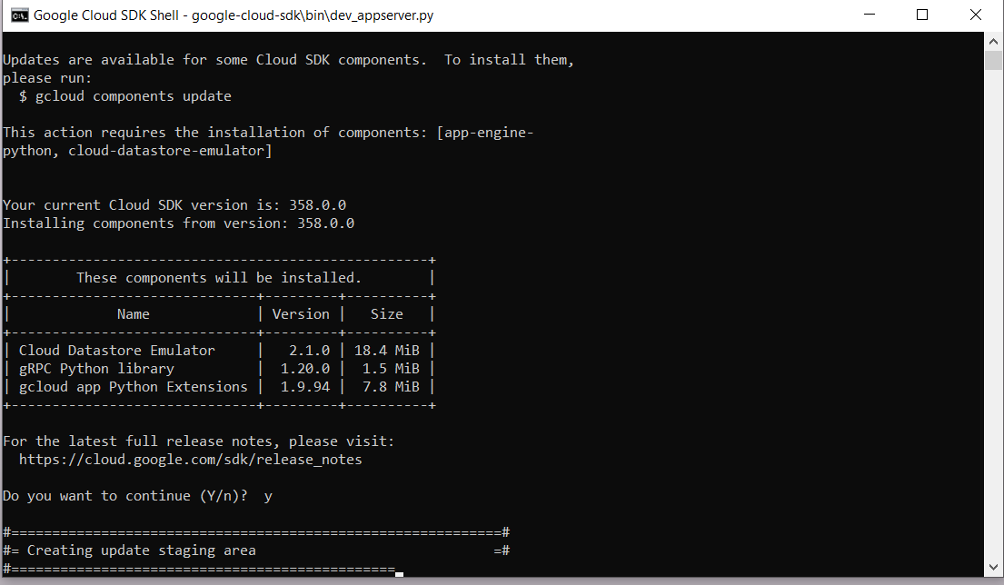

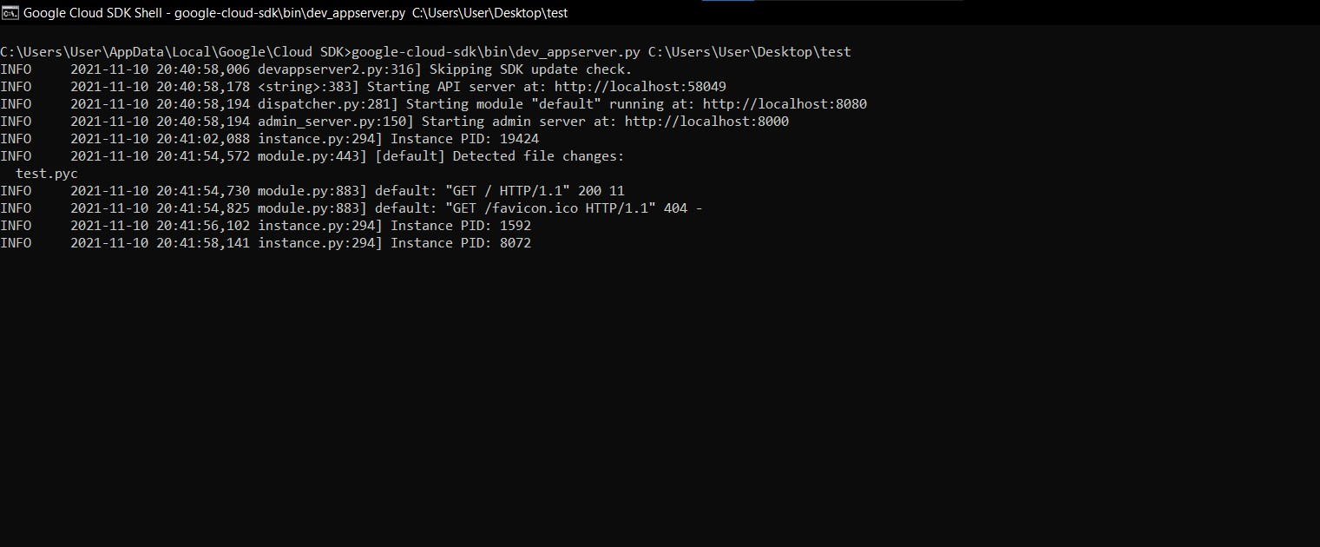

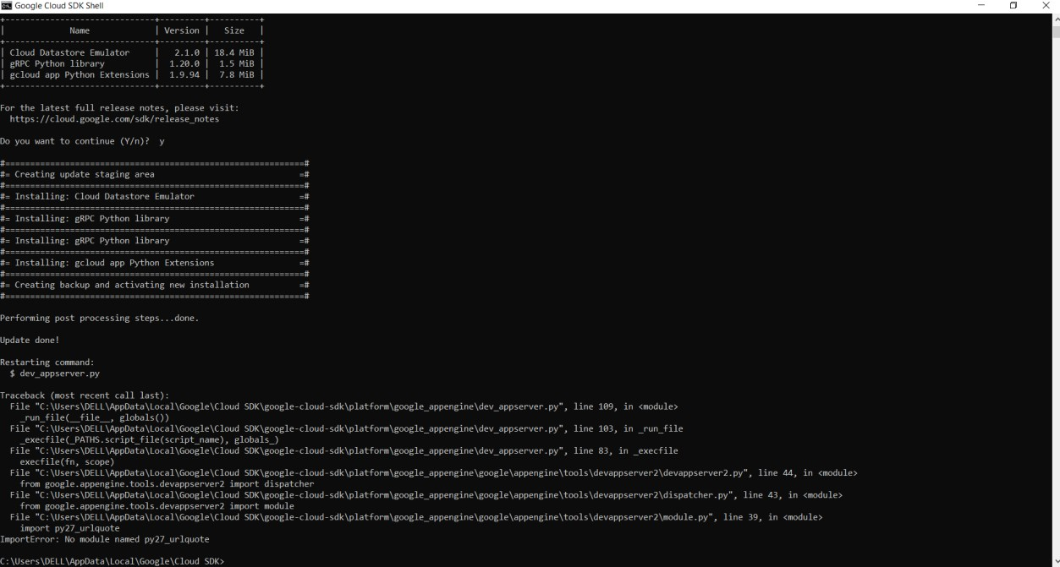

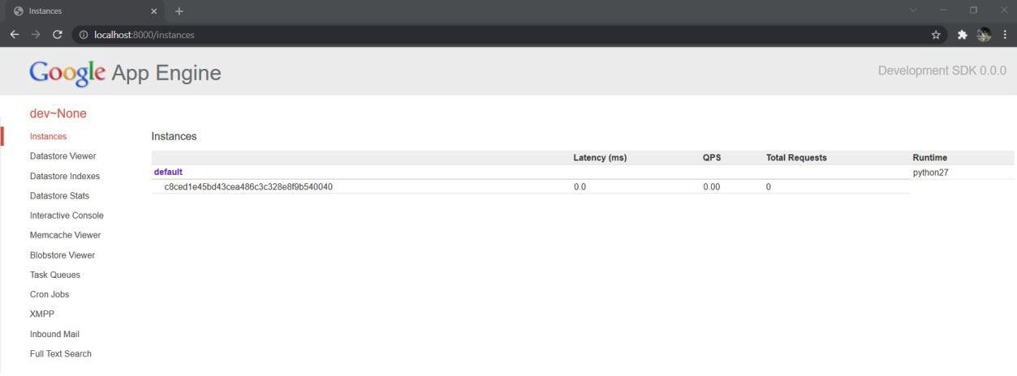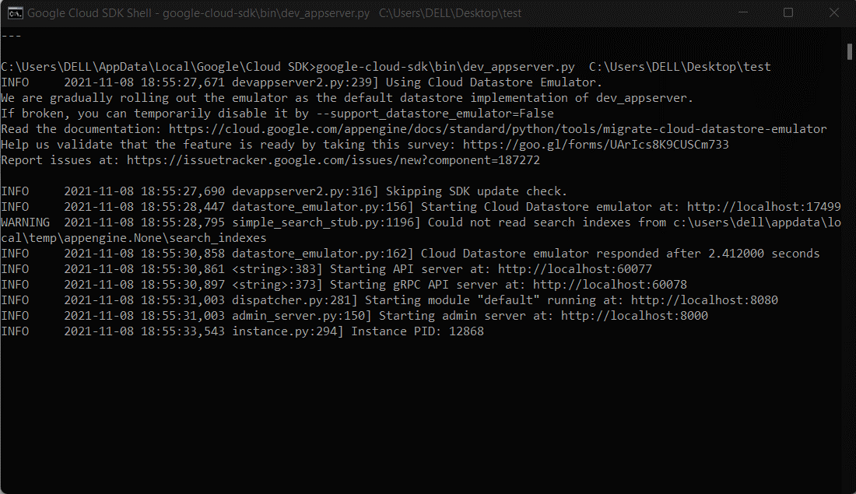



|  |  |
| --- | --- |
| **Observation** |  |
| **Record** |  |
| **Total** |  |
| **Course Incharge** |  |

# Result:

Thus the google app engine is installed and the simple web application using python is created and the output has been verified.

**EX.NO: 6 INSTALLATION OF GOOGLE APP ENGINE & CREATION OF**

**SIMPLE WEB APPLICATION USING JAVA**

**DATE: 01.10.2021**

# AIM:

To install Google App Engine & Creating of Simple Web Application using java

# DESCRIPTION:

Google App Engine is a fully managed serverless platform for developing and hosting web applications at a scale. Users can choose from several popular languages, libraries, and frameworks to develop their applications and then App Engine takes care of provisioning servers and scaling app instances based on demand. It is a PaaS for building scalable applications.

# PROCEDURE:

Step 1: Download the Eclipse for java ide in the official website of Eclipse [www.eclipse.org/downloads/](http://www.eclipse.org/downloads/)

Step 2: Install the JDK 8 in the system in the official Oracle Website

Step 3: Now open the Eclipse Ide and install the Google Cloud Tools plugin

Step 4: Click the Windows tab ➔ Preferences ➔ and find the Google tools and give the google cloud sdk file location.

Step 5: Now the Google Sdk is ready now the next step is to install the java components to the Google cloud sdk

Step 6: Open the Google cloud shell and type the command gcloud components install app-engine- java” to install the java components

Step 7: The command prompt will open type Y(yes) to continue with the installation

Step 8: Then open Eclipse and create the new Web application to do so follow the below steps

Step 9: Look for the google icon and select the java standard app Engine

Step 10: Create the program to display “Hello World ” in the browser

Step 11: Run the program as App engine

Step 12: The output will be displayed on the localhost in the browser.

# OUTPUT:



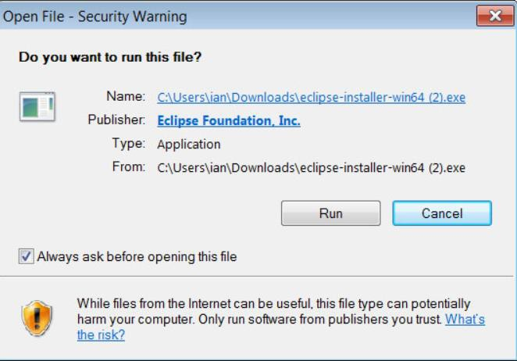

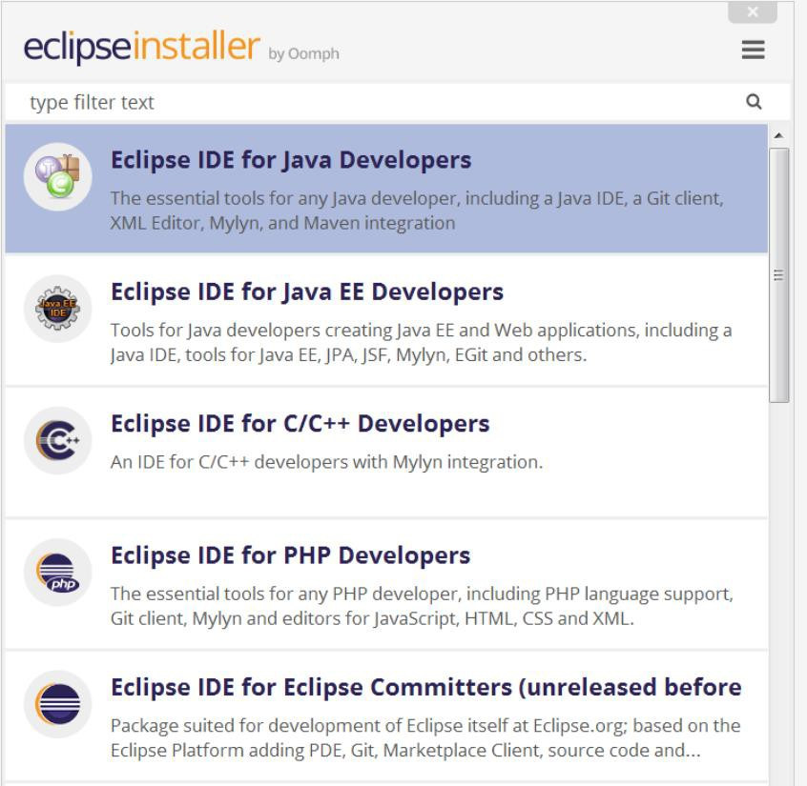

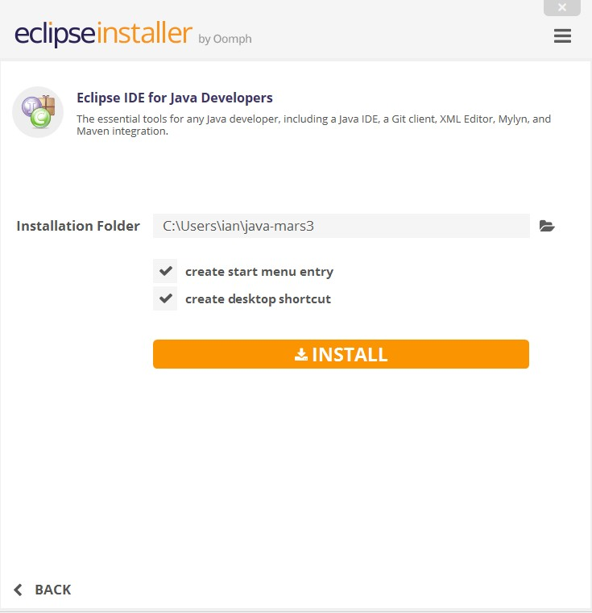

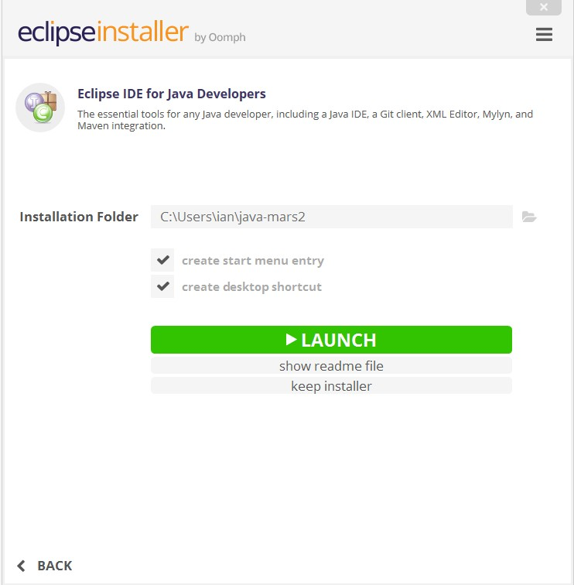

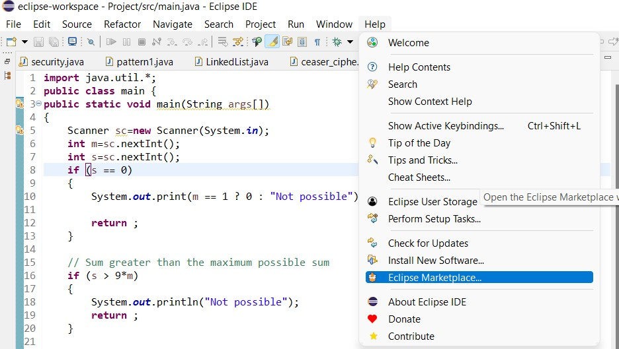

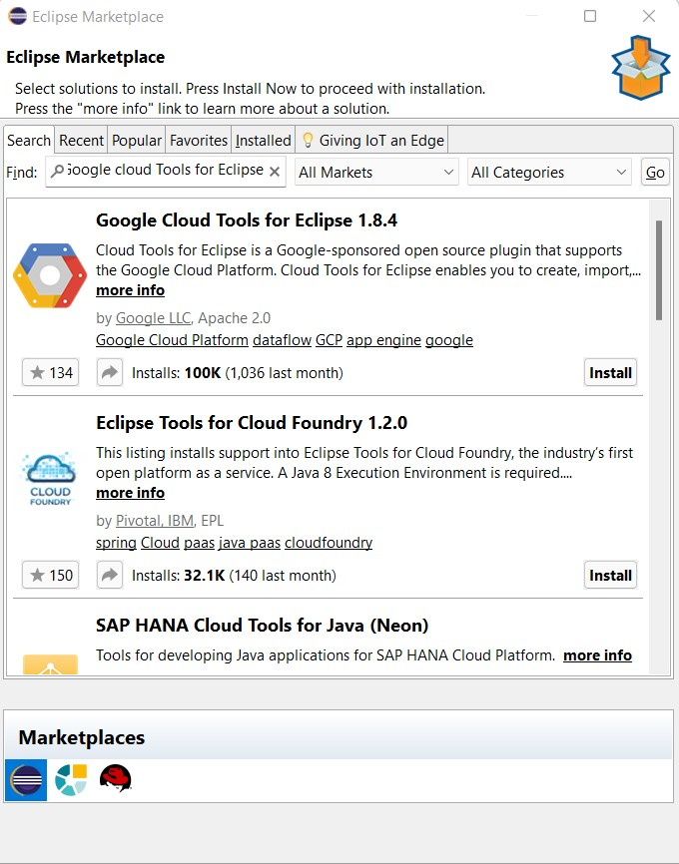

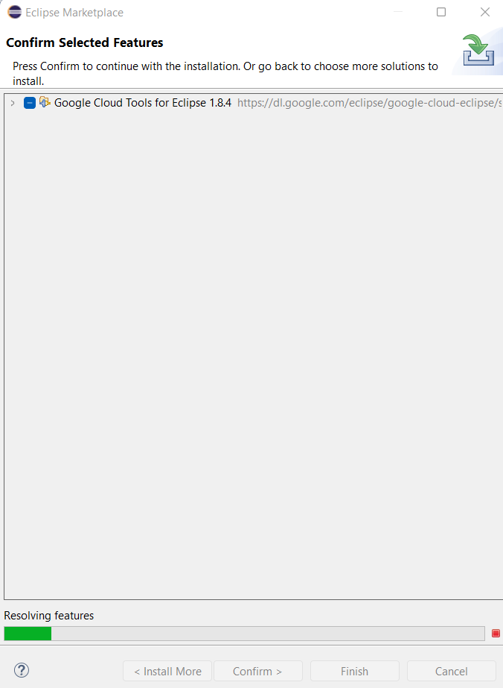

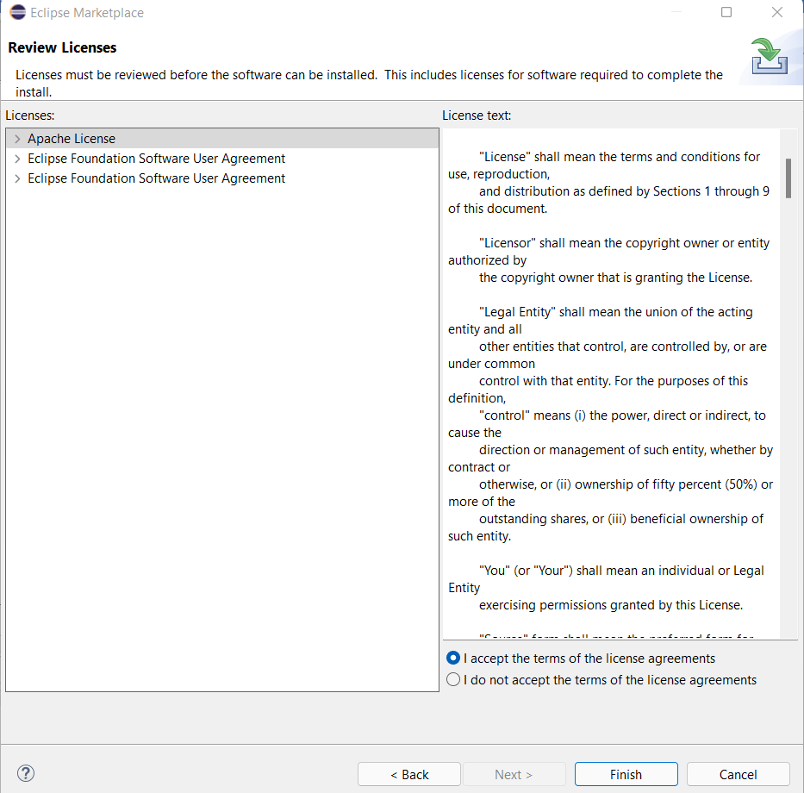

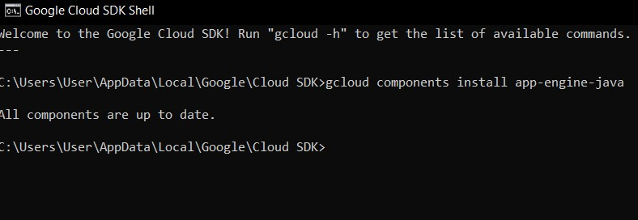

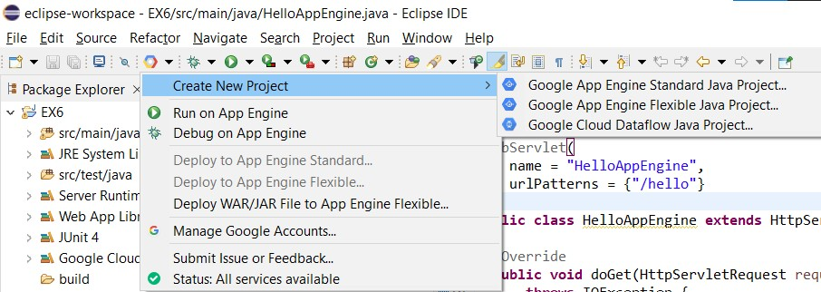

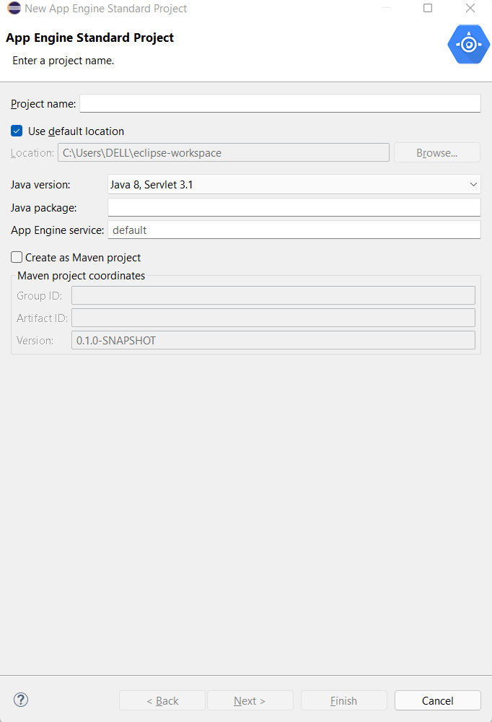

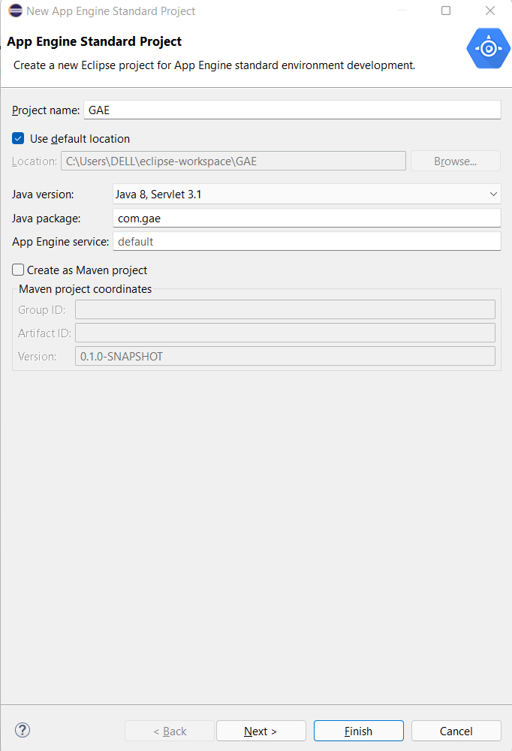

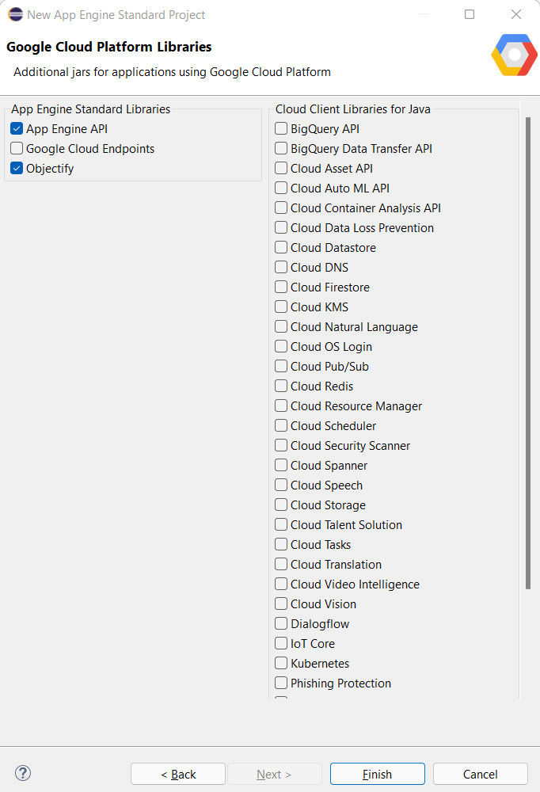

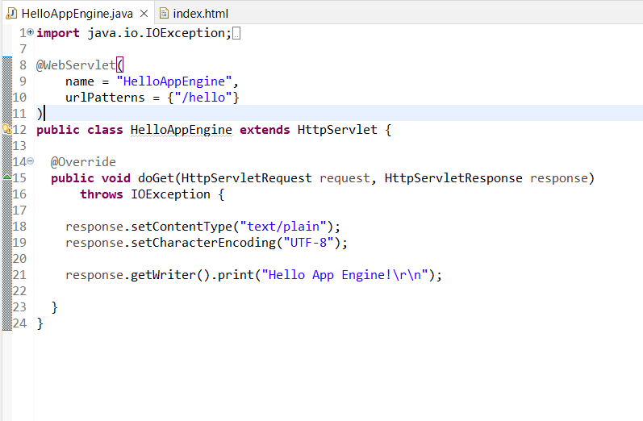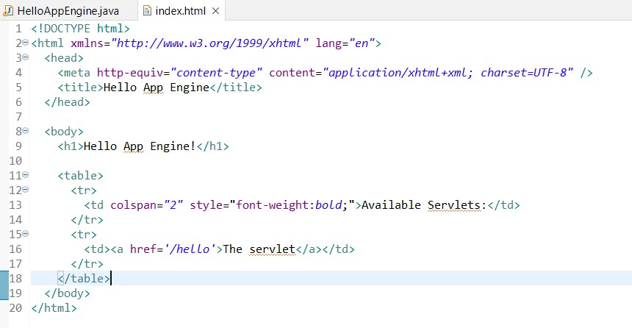

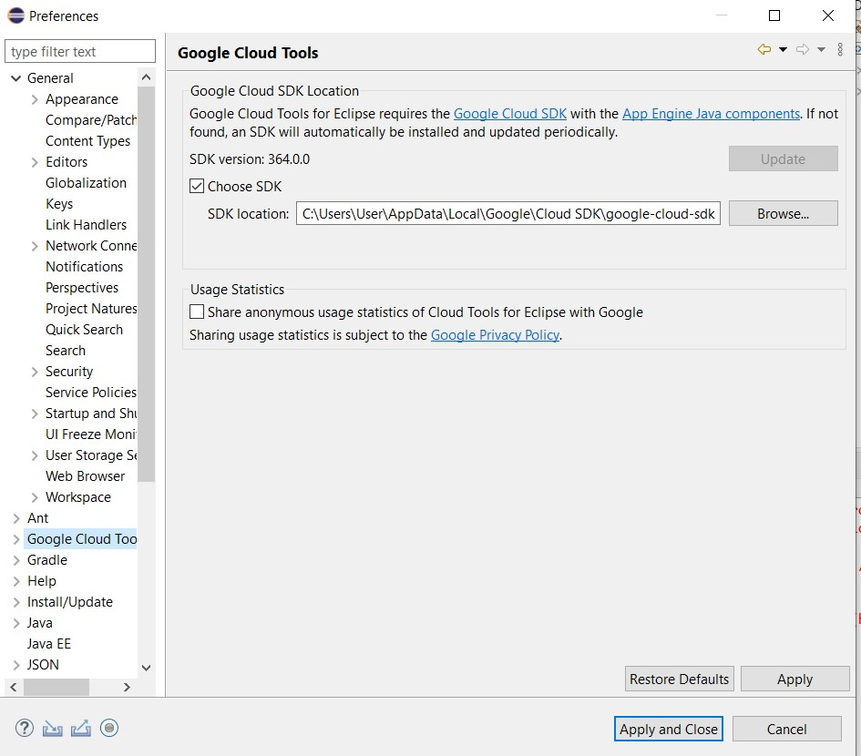

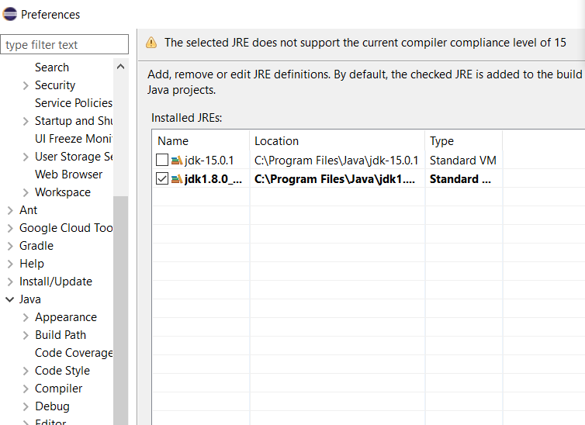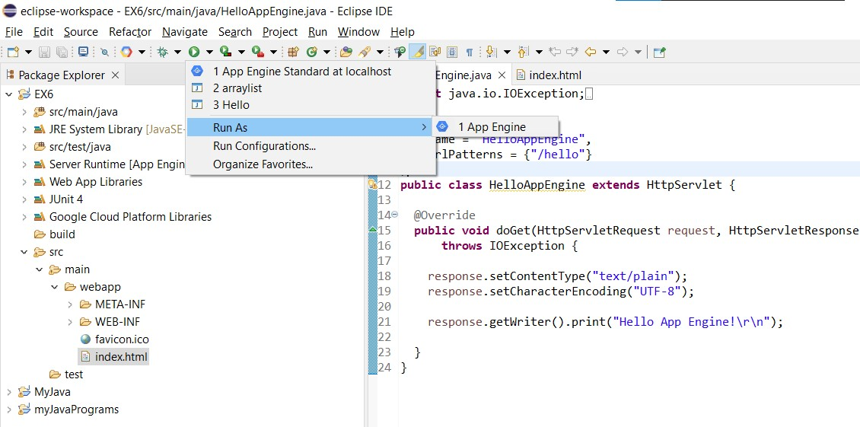

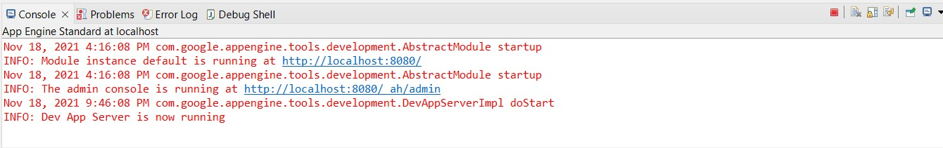





|  |  |
| --- | --- |
| **Observation** |  |
| **Record** |  |
| **Total** |  |
| **Course Incharge** |  |

# RESULT:

Thus, the google app engine is installed and the simple web application using java is created and the output has been verified.

**EX NO: 7 SIMULATING CLOUD SCENARIO USING CLOUDSIM TO RUN**

**SJF/ROUNDROBIN SCHEDULING ALGORITHM.**

**DATE: 25.10.2021**

**AIM:**

To simulate a cloud scenario using CloudSim and running a scheduling Algorithm.

**PROCEDURE:**

**CloudSim**

* A Framework for modeling and simulation of Cloud Computing Infrastructures and services
* Originally built at the Cloud Computing Distributed Systems (CLOUDS) Laboratory, The University of Melbourne, Australia
* It is completely written in JAVA

**Procedure to import Eclipse, running scheduling algorithms in your system**

**Step 1:** Link to download Eclipse and download Eclipse for Windows 64bit into your Local

Machine.

https://www.eclipse.org/downloads/packages/release/kepler/sr1/eclipse-ide-java-developers

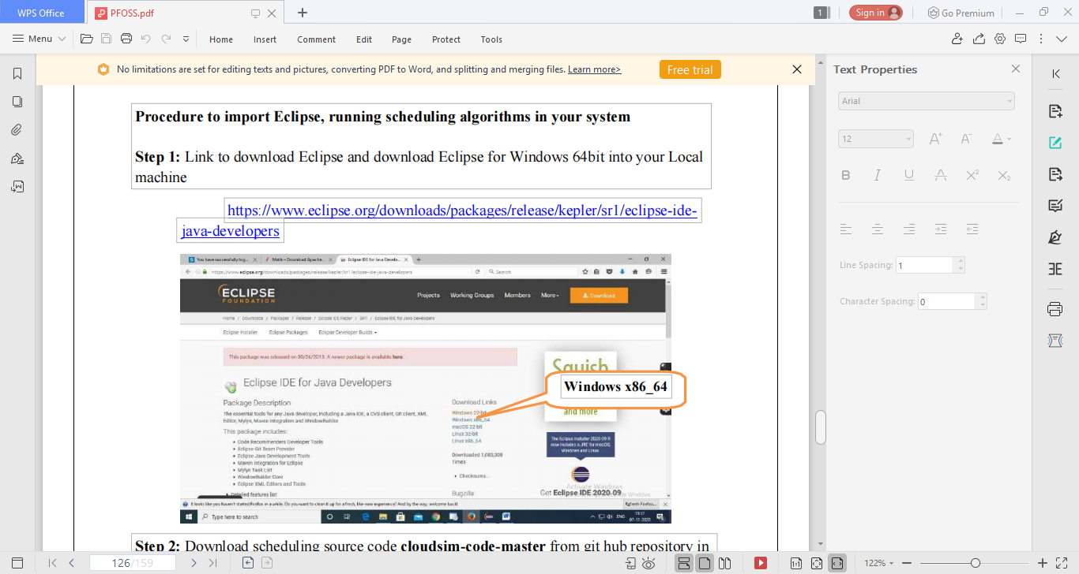

**Step 2:** Download scheduling source code **cloudsim-code-master** from git hub repository in

your local machine.

<https://github.com/shiro873/Cloudsim-Code>

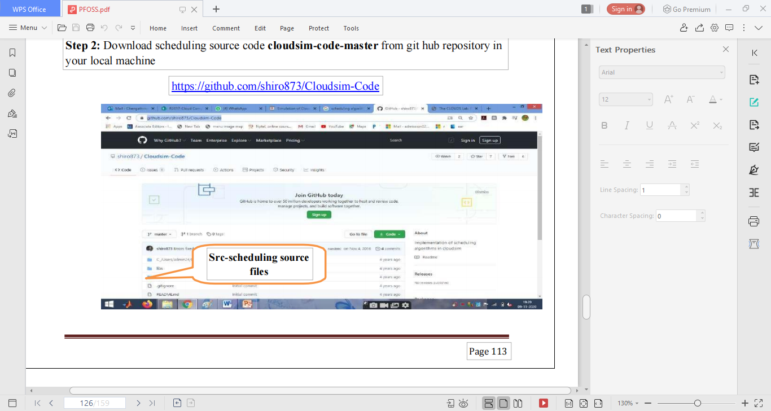

**Step 3:** Download commons-maths3-3.6.1 from git hub repository in your local machine.

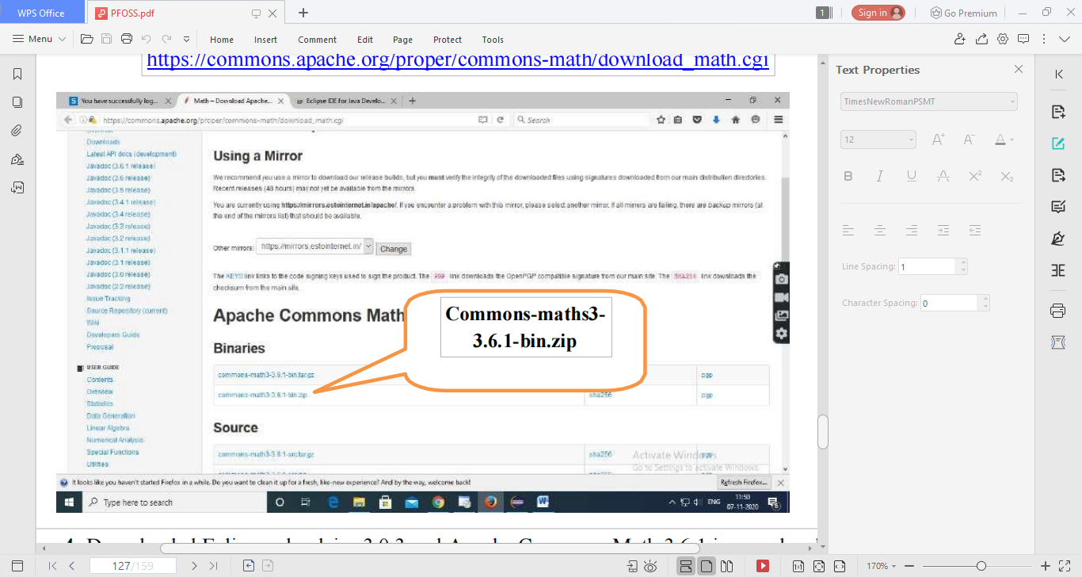

**Step 4:** Downloaded Eclipse, cloudsim-3.0.3 and Apache Commons Math 3.6.1 in your local

machine and extract cloudsim-3.0.3 and Apache Commons Math 3.6.1.

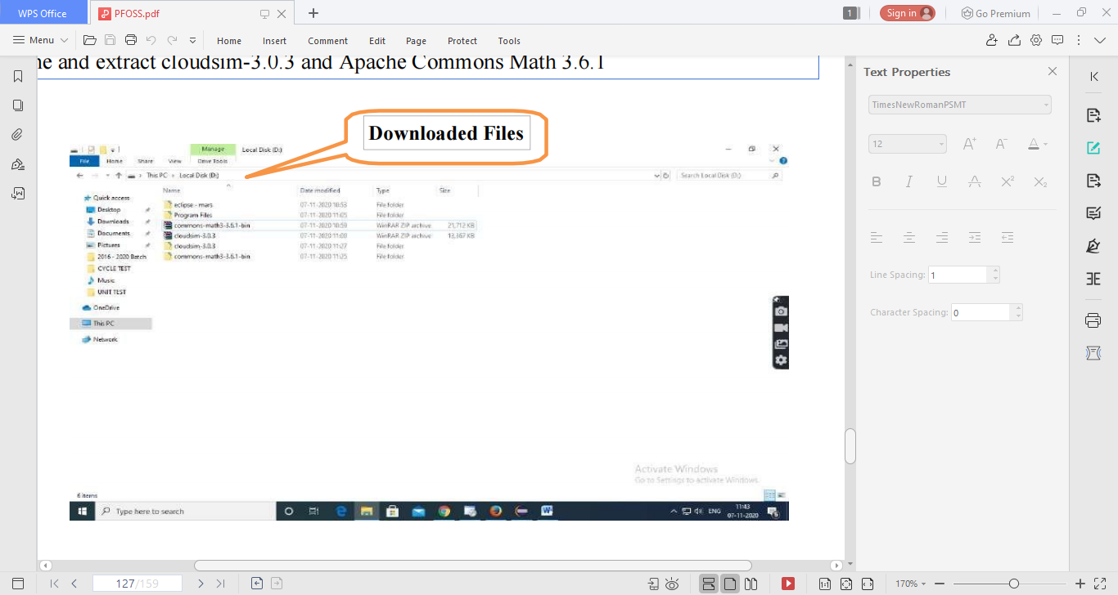

**Step 5:** F irst of all, navigate to the folder where you have unzipped the eclipse folder and

open Eclipse.exe.

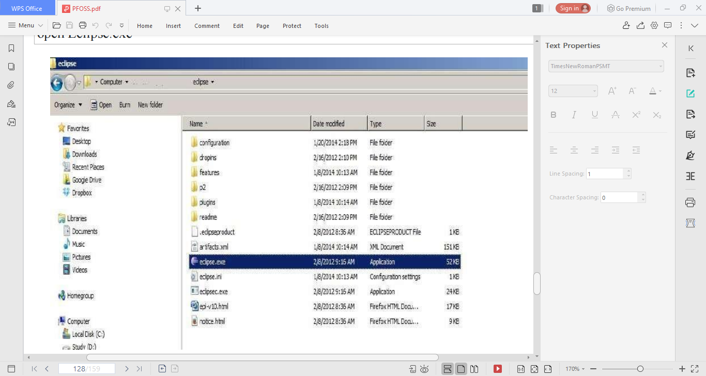

**Step 6:** N ow within Eclipse window navigate the menu: *File -* *> New -> Project,* to open the

new project wizard.

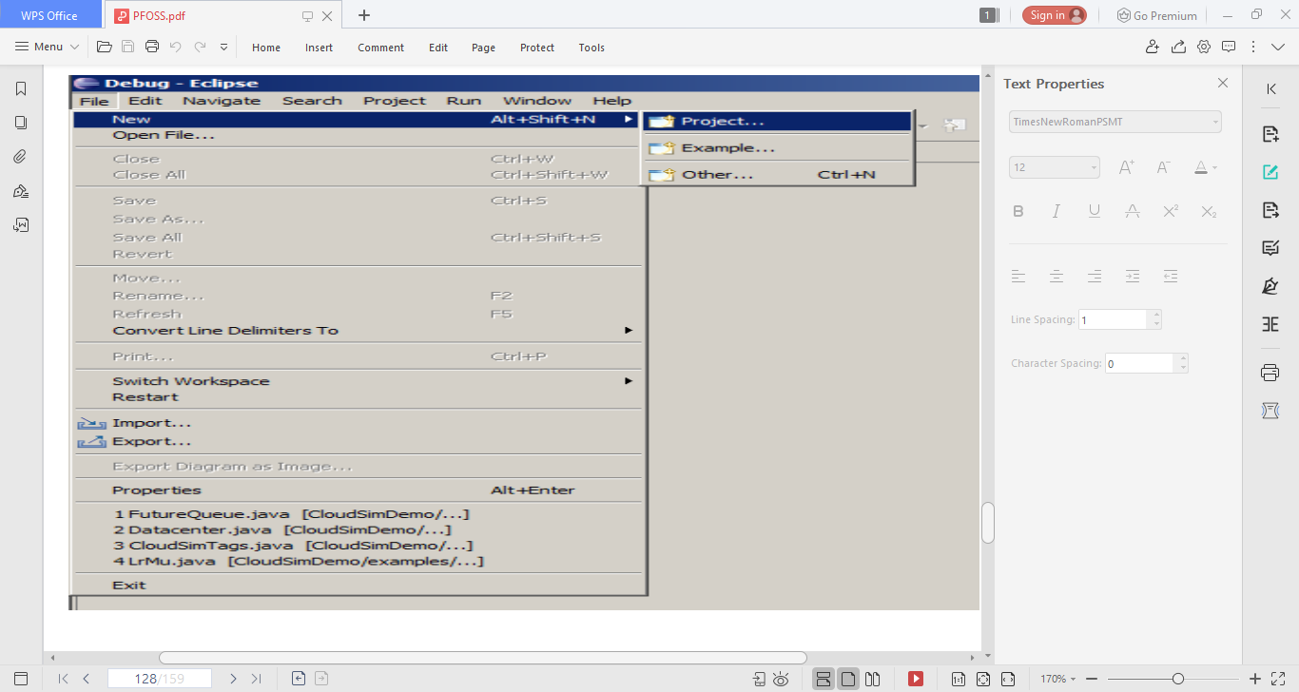

**Step** **7:** A ‗*New* *Project*‗ wizard should open. There are a number of options displayed and

you have to find & select the ‗*Java Project*‗ option, once done click *‘Next*‗’.

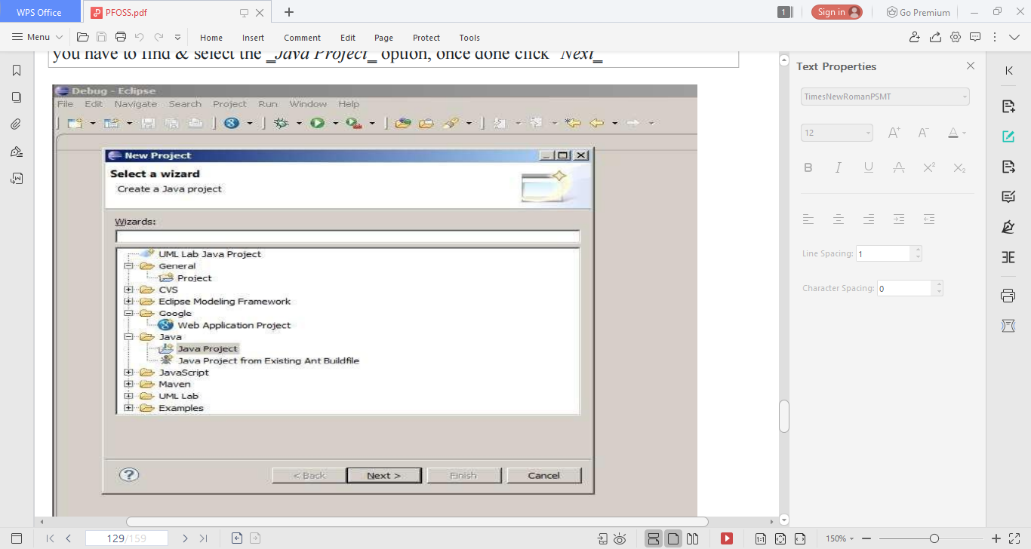

**Step 8:** Now a detailed new project window will open, here you will provide the project name

and the path of CloudSim-master-code project source code, which will be d one as follows:

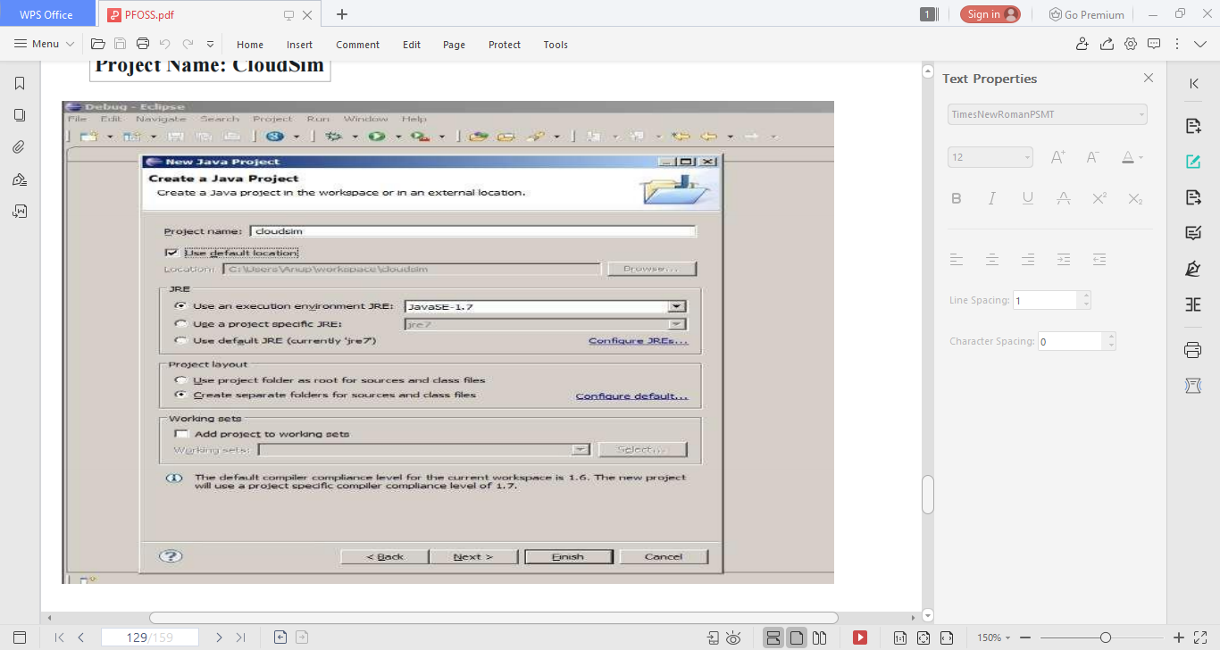

**Step 9:** Unselect the *‘Use default location’* o ption and then click on *‘Browse’* t o open the path

where you have unzipped the C loudsim-code-master project and finally click Next to set project

settings.

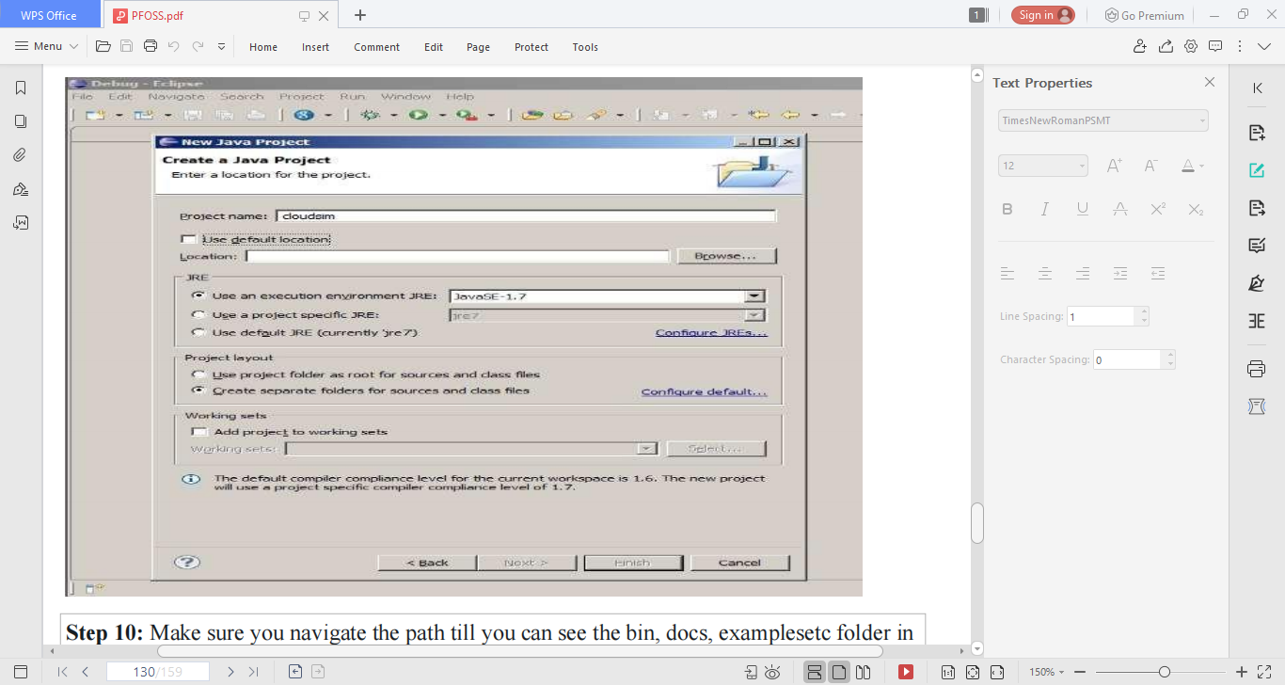

**Step 10:** Make sure you navigate the path till you can see the bin, docs, examplesetc folder in

the navigation plane.

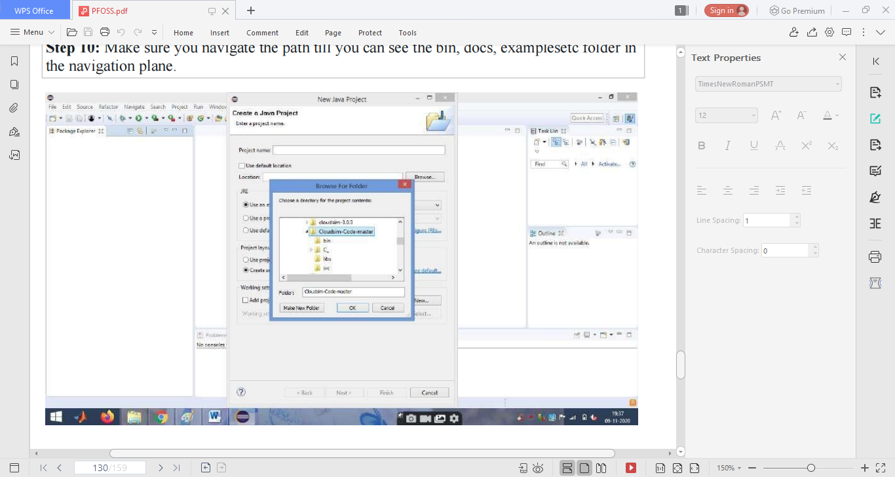

**Step** **11:** Once done finally, click ‗Next‘ to go to the next step i.e. setting up of project

Settings.

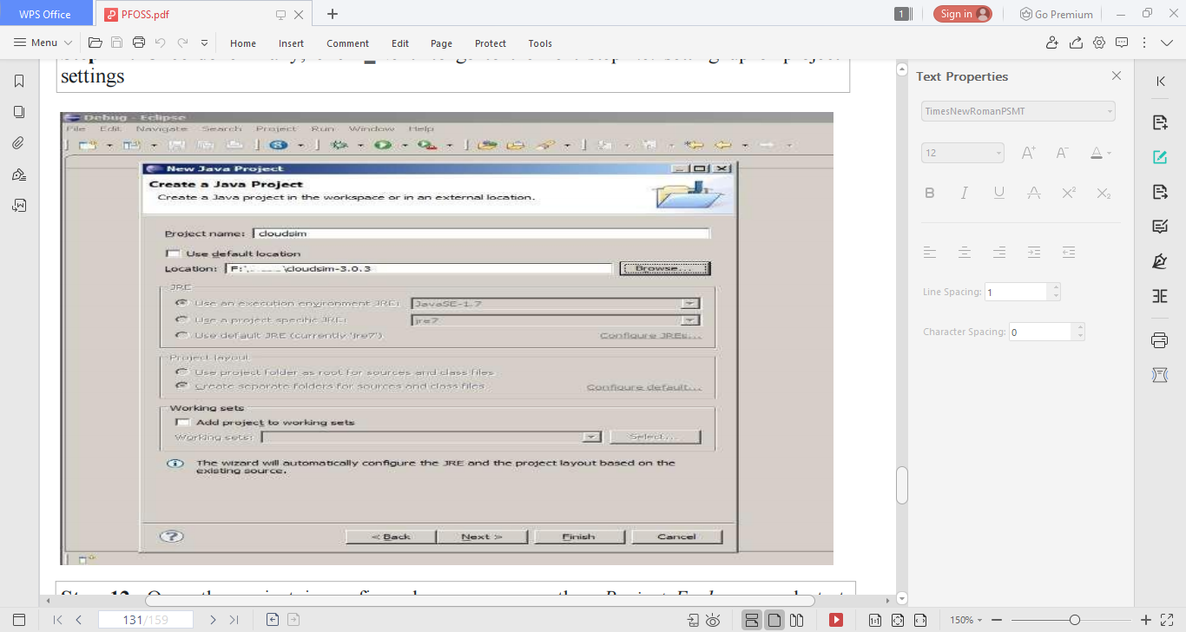

**Step 12:** Once the project is configured you can open the ‗*Project Explorer*‗ and start

exploring the Cloudsim project. Also for the first time eclipse automatically start building the

workspace for newly configured Cloudsim project, which may take some time depending on

the configuration of the computer system.

Following is the final screen which you will see after Cloudsim is configured.

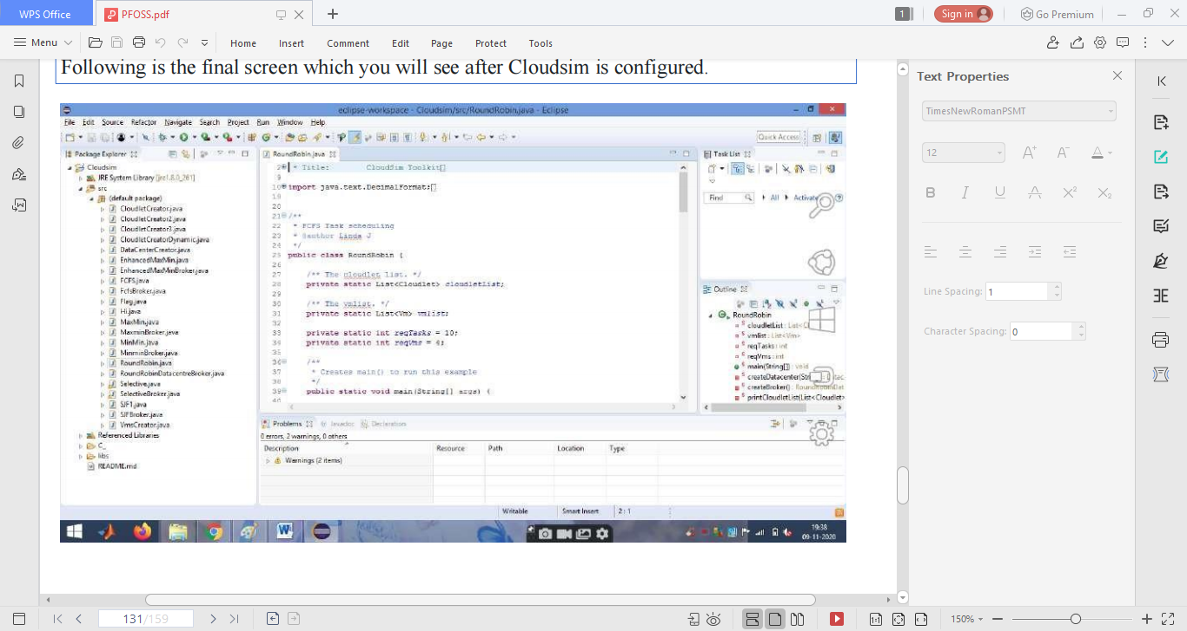

**Step** **13:** Now just to check you within the ‗**Project** **Explorer**‗, you should navigate to the

‗**src**‗ folder, then expand the package ‗*default package*‗ and double click to open the

‗R*oundRobin.java*‗.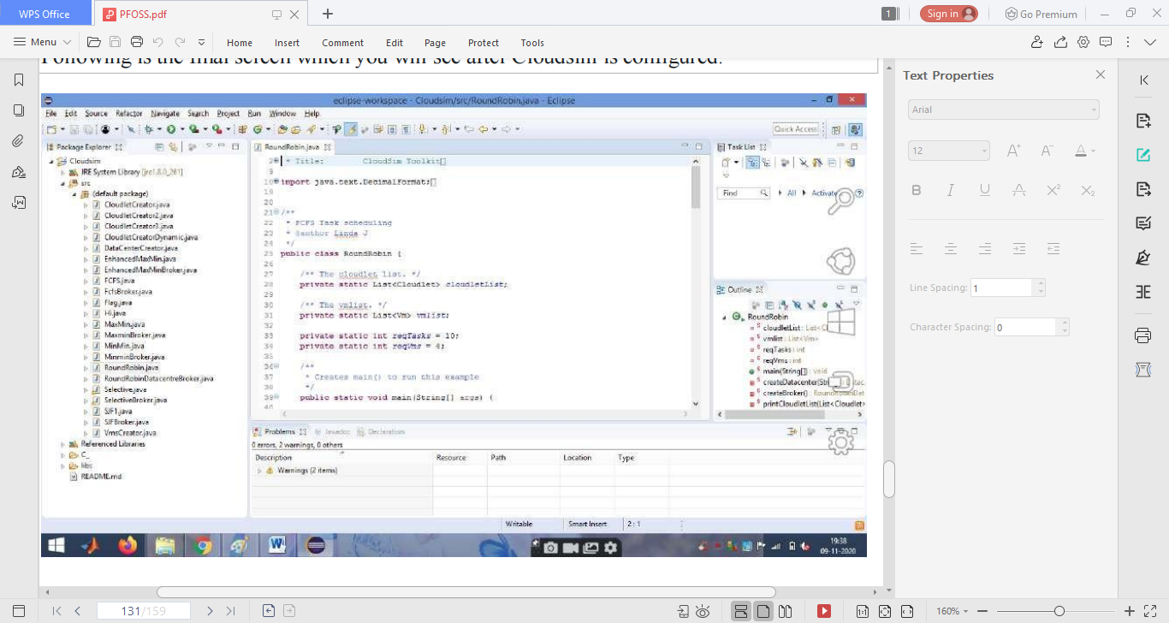

**Step 14:** N ow navigate to the Eclipse menu ‗*Run -* *>Run*‗ or directly use a keyboard shortcut*‘Ctrl + F11’* to execute the *‘RoundRobin*.java‘. If it is successfully executed it should be displaying the following type to output in t he console window of the Eclipse IDE.

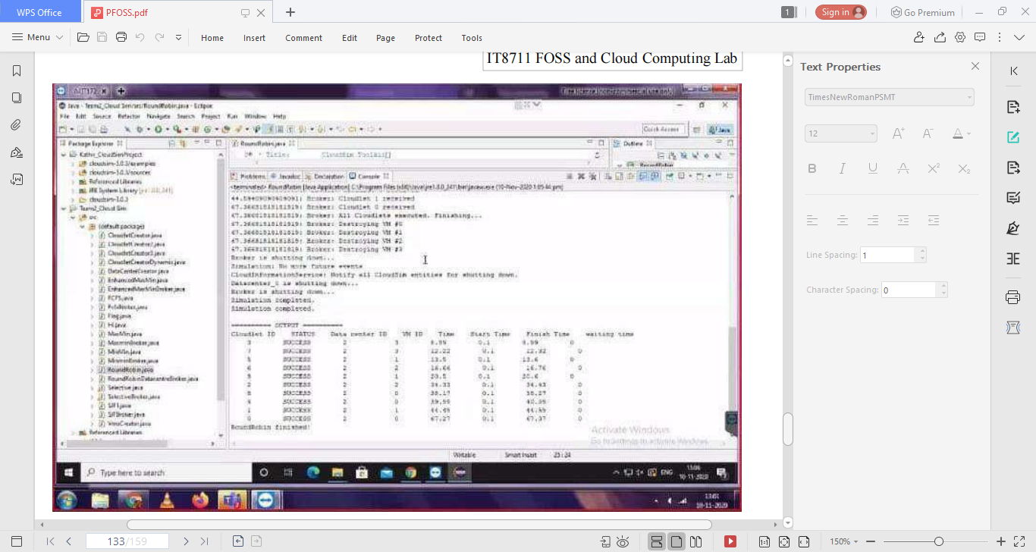

|  |  |
| --- | --- |
| **Observation** |  |
| **R Record** |  |
| **T Total** |  |
| **C Course Incharge** |  |

**RESULT:**

Thus the scheduling algorithm is executed in cloudsim is simulated using Eclipse

Environment successfully.

**EX NO:** **8 INSTALLATION OF HADOOP SINGLE NODE CLUSTER TO RUN**

**WORD COUNT APPLICATION**

**DATE: 02.11.2021**

**AIM:**

To install Hadoop single node cluster to run word count application

**PROCEDURE:**

**HADOOP**

Apache Hadoop is a collection of open-source software utilities that facilitates using a network of many computers to solve problems involving massive amounts of data and computation.

It provides a software framework for distributed storage and processing of big data using the MapReduce programming model.

1. Install Java
2. Configure and install hadoop
3. Test hadoop installation
4. Create wordcount program
5. Input file to mapreduce
6. Display the output

**Step 1. JAVA Installation**

1. Go to official Java Downloading page

<https://www.oracle.com/java/technologies/javase-jre8-downloads.html>

1. After downloading java, run the  **jdk-8u241-windows-x64.exe**file
2. Follow the instructions and click next.
3. After finishing the installation it is need to set Java environment variable
4. Go to Start->Edit the System environment variable->Environment variable
5. Then Click new and enter variable name as “JAVA_HOME”
6. In the value field Enter the java path such as “C:\Java\jdk1.8.0_241”(Consider your installation folder)

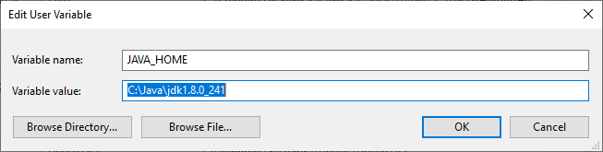

8. Go to path and click edit then type “%JAVA_HOME%\bin”



9. Then click Ok and Go to Command Prompt

10. Type “Java -version”. If it prints the installed version of java, now java successfully installed in your System.

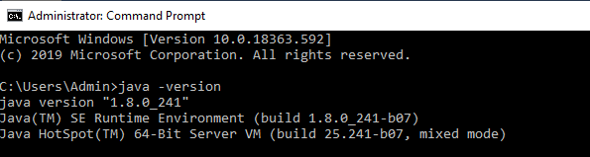

**Step 2.    Configuring And Installing Hadoop**

1. Download Hadoop 2.8.0 from [http://archive.apache.org/dist/hadoop/core//hadoop-2.8.0/hadoop- 2.8.0.tar.gz](http://archive.apache.org/dist/hadoop/core/hadoop-2.8.0/hadoop-%202.8.0.tar.gz))

2. Extract the tar file ( in my case I used **7-zip** to extract the file and I stored the extracted file in the **D:\hadoop**)

3. After finishing the extraction it is need to set Hadoop environment variable

4. Go to Start->Edit the System environment variable->Environment variable

5. Then Click new and enter variable name as “HADOOP_HOME”

6. In the value field Enter the java path such as “D:\hadoop”(Consider your installation folder)

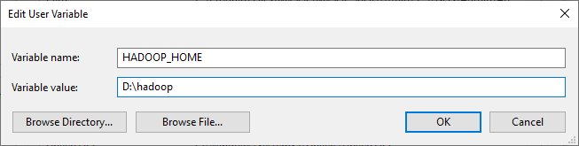

7. Go to path and click edit then type “%HADOOP_HOME%\bin”



8.  Now we have to configure the hadoop.

9. Go to D:/hadoop/etc/hadoop/.. folder, find the below mentioned files and paste the following.

**i. core-site.xml**

**ii.**Rename "**mapred-site.xml.template**" to "**mapred-site.xml**" and edit this fileD:/Hadoop/etc/hadoop/mapred-site.xml, paste below xml paragraph and save this file.

<configuration>

<property>

<name>mapreduce.framework.name</name>

<value>yarn</value>

</property>

</configuration>

**iii.** Create folder "data" under "D:\Hadoop"

* Create folder "datanode" under "D:\Hadoop\data"
* Create folder "namenode" under "D:\Hadoop\data" data

**iv. hdfs-site.xml**

<configuration>

<property>

<name>dfs.replication</name>

<value>1</value>

</property>

<property>

<name>dfs.namenode.name.dir</name>

<value>D:\hadoop\data\namenode</value>

</property>

<property>

<name>dfs.datanode.data.dir</name>

<value>D:\hadoop\data\datanode</value>

</property>

</configuration>

**v.  yarn-site.xml**

<configuration>

<property>

<name>yarn.nodemanager.aux-services</name>

<value>mapreduce_shuffle</value>

</property>

<property>

<name>yarn.nodemanager.auxservices.mapreduce.shuffle.class</name>

<value>org.apache.hadoop.mapred.ShuffleHandler</value>

</property>

</configuration>

**vi.**Edit file D:\Hadoop\etc\hadoop\**hadoop-env**.cmd by closing the command line "JAVA_HOME=%JAVA_HOME%" instead of set "JAVA_HOME= C:\Java\jdk1.8.0_241" (if your java file in Program Files the instead of give **Progra~1**otherwise you will get JAVA_HOME incorrectly set error)

**vii.**Download file Hadoop Configuration.zip <https://github.com/Prithiviraj2503/hadoop-installation-windows>

**viii.**Delete file bin on D:\Hadoop\bin and replace it by the bin file of Downloaded configuration file (from Hadoop Configuration.zip).

**ix.**Open cmd and typing command "**hdfs namenode –format**" .You will see through command prompt which tasks are processing, after competeation you will get a massage like namenode format succesfully and shutdown message

hdfs namenode –format

**step 3. Testing Hadoop Installation**

1. Open Cmd and type the following “Hadoop -version”

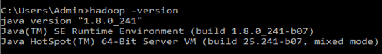

2. To start the hadoop locate to “D:\hadoop\sbin” via command prompt and press **start-all.cmd**

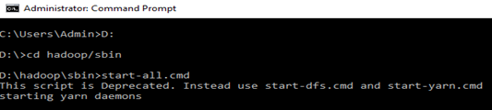

Now, you can see the namenode, datanode and yarn engines getting start,

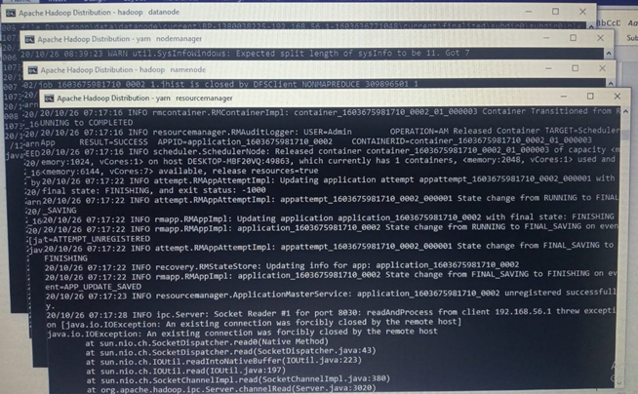

3. Now type “jps”. JPS (Java Virtual Machine Process Status Tool) is a command is used to check all the Hadoop daemons like NameNode, DataNode, ResourceManager, NodeManager etc.

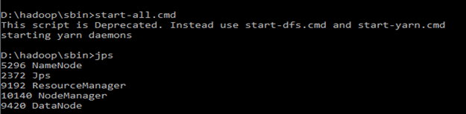

4. Open: [http://localhost:8088](http://localhost:8088/) in any browser

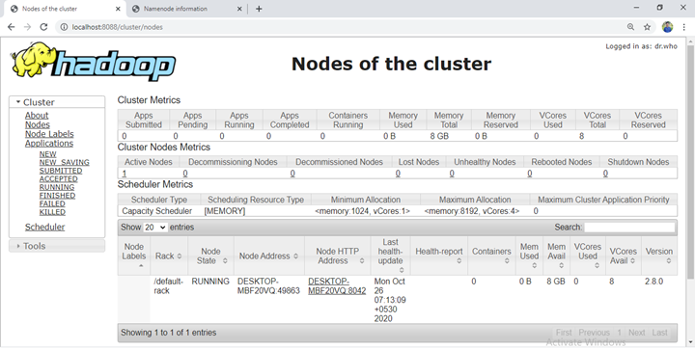

5. Open: [http://localhost:50070](http://localhost:50070/) in any browser

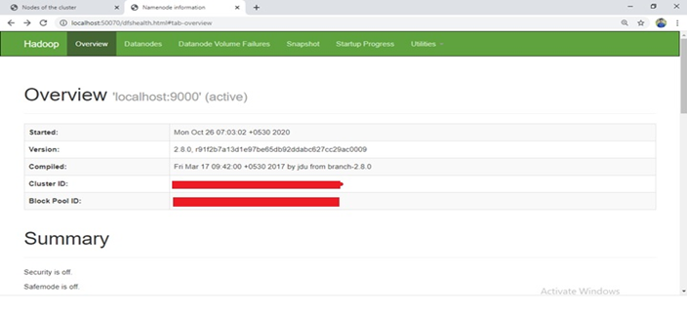

Now hadoop succesfully installed in the System.

**Step4.  Simple WordCount Program**

1) After successful hadoop installation we need to create an directory in the hadoop file system

2) Start the hadoop via command prompt **$ start-all.cmd**

3) By using **$jps**command Ensure hadoop nodes are running

4) To create a directory, use: **$ hadoop fs –mkdir /inputdir**

5) To input a file within a directory, use: **$ hadoop fs –put D:/input_file.txt/inputdir**

6) To ensure wether your file succesfully imported, use: **$ hadoop fs  –ls /inputdir/**

7) To view the content of the file, use:**$ hadoop dfs –cat /inputdir/input_file.txt**

Link for input file : <https://github.com/Prithiviraj2503/hadoop-installation-windows>

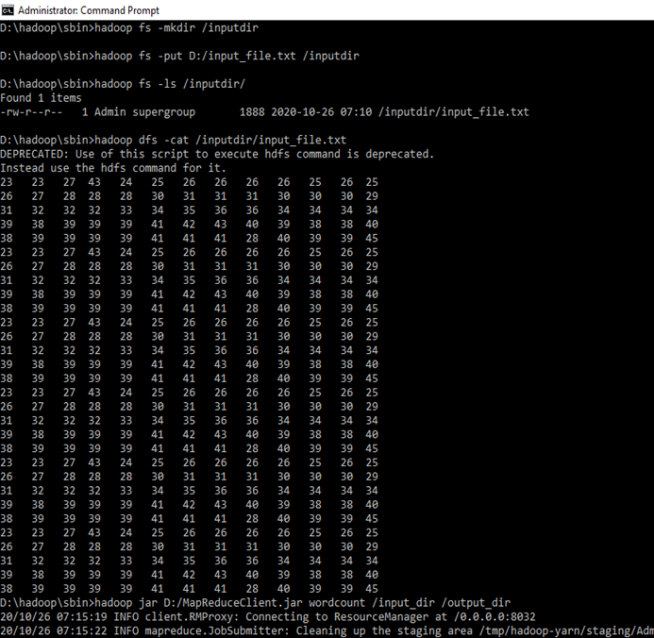

8) Now appy mapreduce program to the input file. We have a **mapReduceClient.jar** which contain java mapper and reducer programs. After applying the jar file you can see the task performed in the mapreduce phase.All the resuts of completed tasks will be printed in the command prompt.

Link for mapReduceClient.jar : <https://github.com/Prithiviraj2503/hadoop-installation-windows>

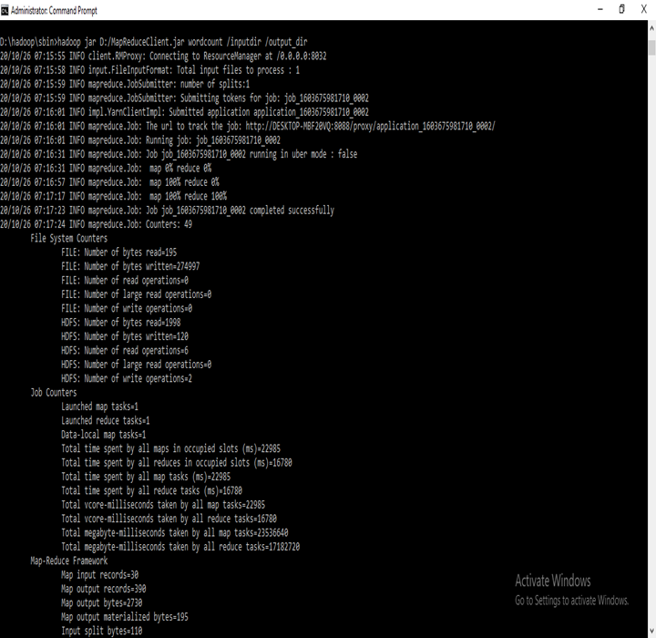

9) After completed the mapreduce tasks the output will be stored in the **output_dir** directory To see the output, use: **$ hadoop dfs –cat /output_dir**/

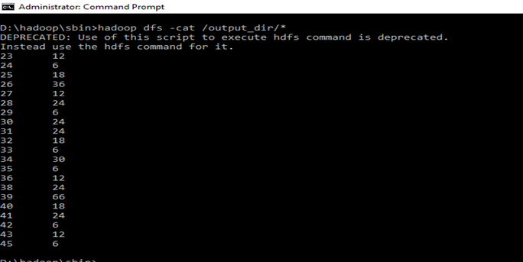

10) To stop the hadoop type **$stop-all.cmd**

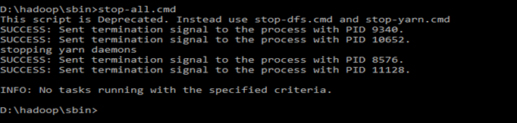

|  |  |
| --- | --- |
| **Observation** |  |
| **R Record** |  |
| **T Total** |  |
| **C Course Incharge** |  |

**RESULT:**

The hadoop single node cluster was installed succesfully and the simple word count program were executed succesfully in the windows system.